Dated

24.03.2024

**Handson VPC , How to Connect and upgrade EBS Volume in Windows EC2 Instance**

**AWS - VPC (Virtual Private Cloud) Tutorial in Hindi | Public, Private subnets, IGW, NAT Gateway**

**Go to AWS Console and Create VPC**

**AWS VPC (Virtual Private Cloud) from scratch, We will also see what are :-**

**1. Route Tables**

**2. Internet Gateway**

**3. NAT Gateway**

**4. Public Subnet**

**5. Private Subnet**

**and also how to create all these!!!**

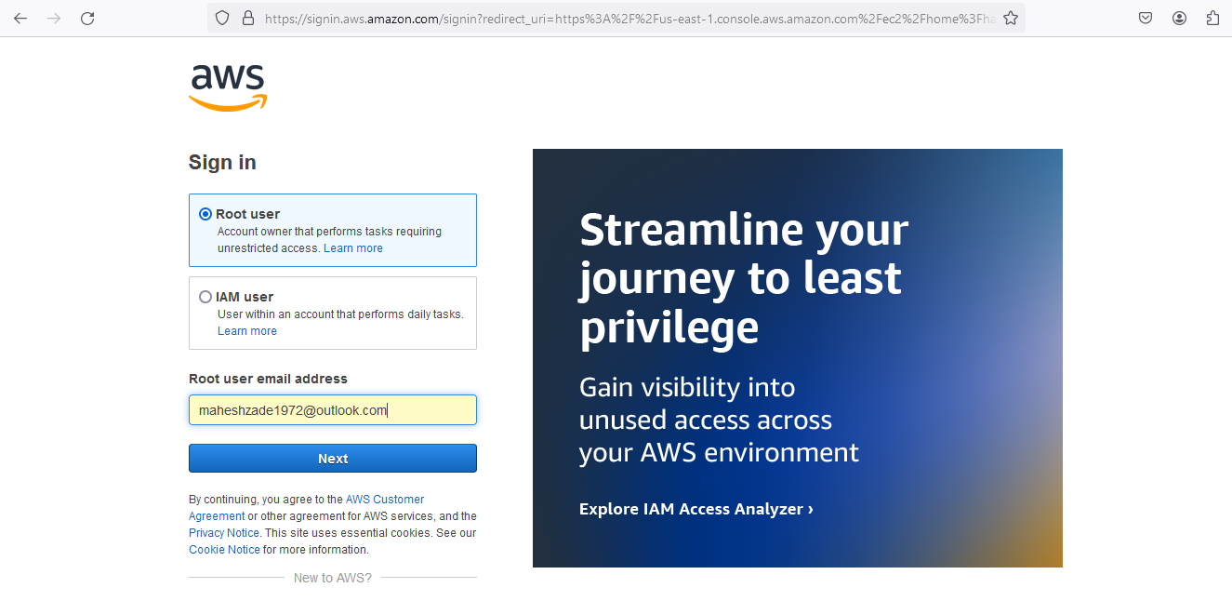

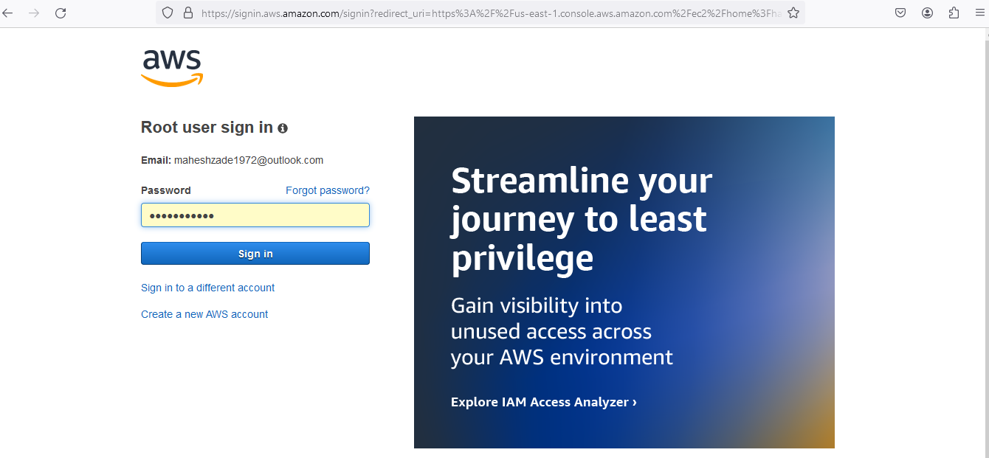

**Go to VPC and Select the Region N Virginia ( Any Region )**

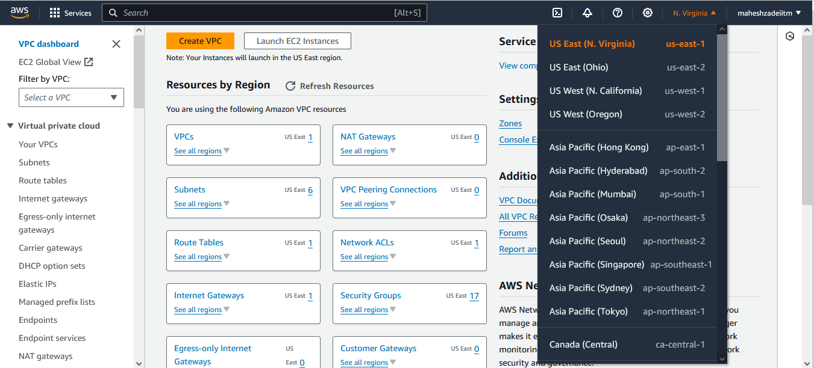

**Click Create VPC**

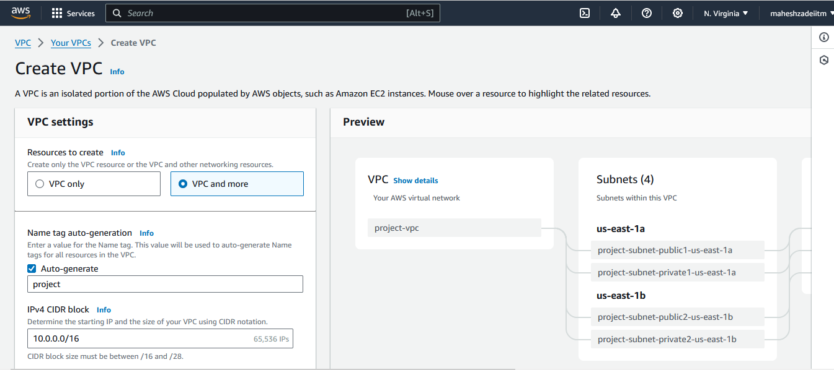

**Click on Create VPC only**

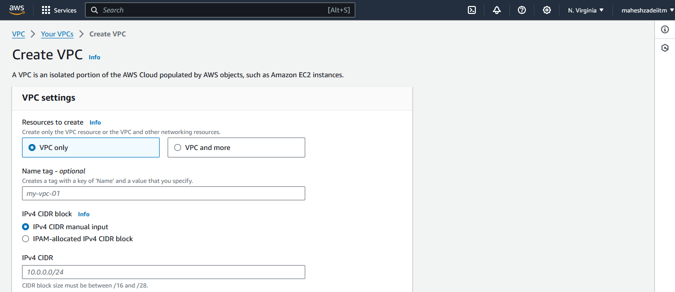

**Tag name and put the CIDR value 10.0.0.0/24**

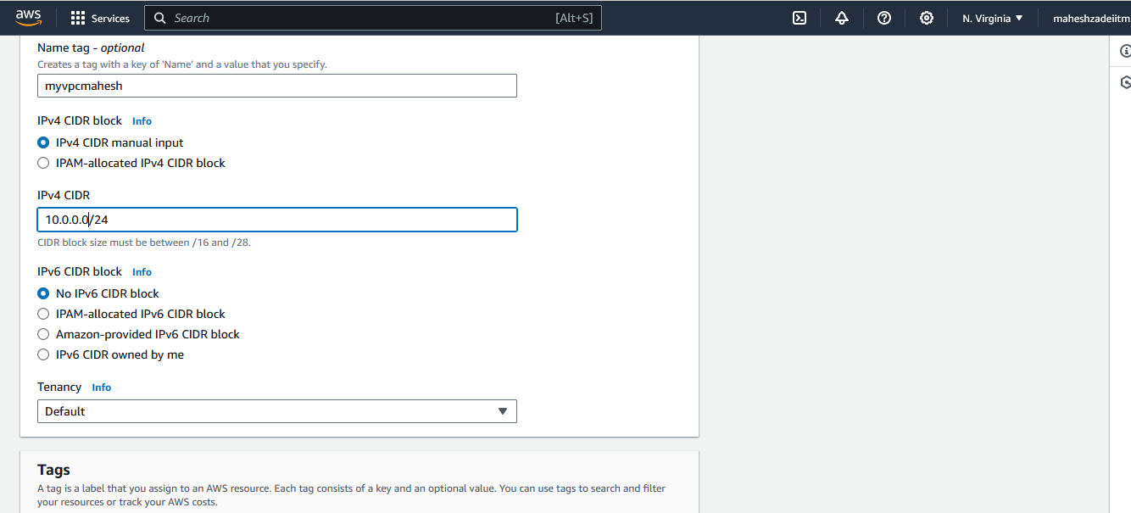

**Click rest as it is and click on Create VPC**

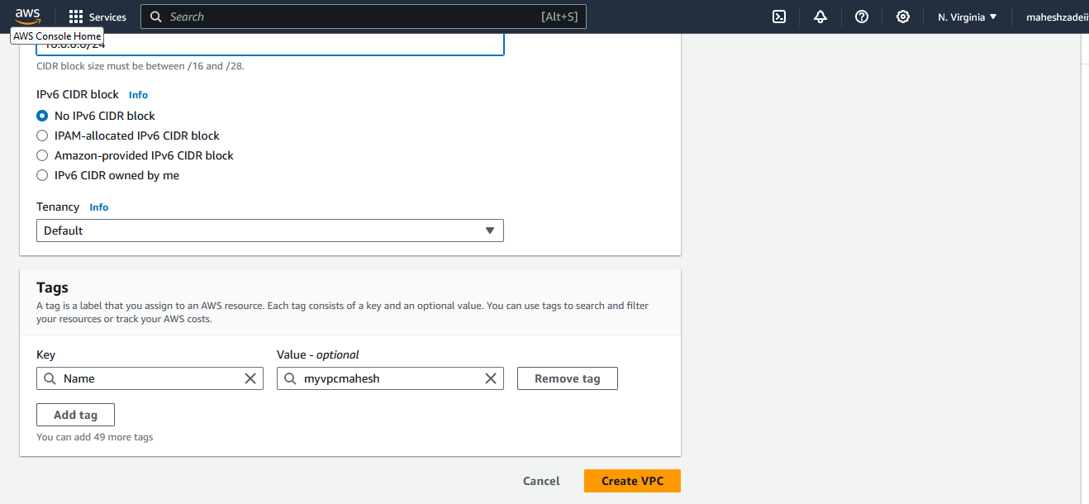

**VPC Created**

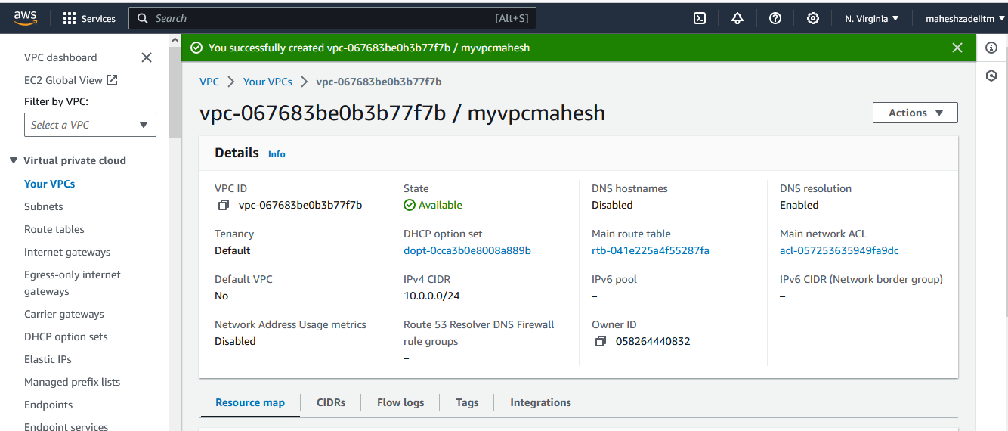

**Go to your VPC check it is available**

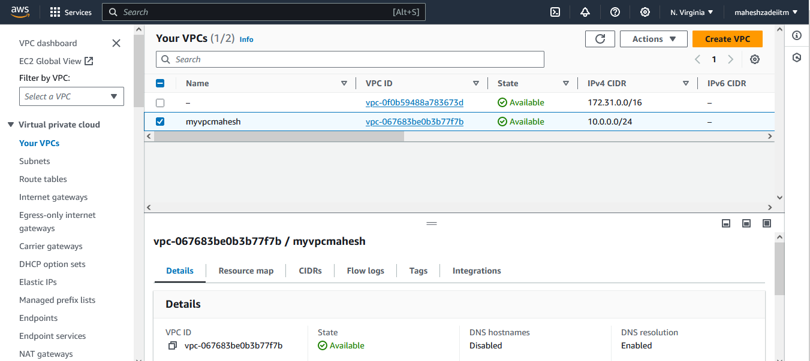

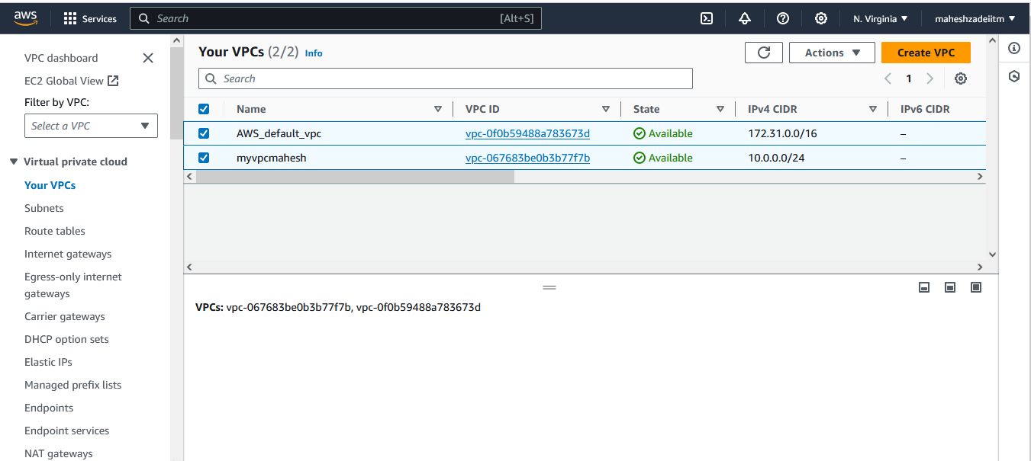

**Now Go to below link for the subnet IP calculator**

[**https://www.davidc.net/sites/default/subnets/subnets.html**](https://www.davidc.net/sites/default/subnets/subnets.html)

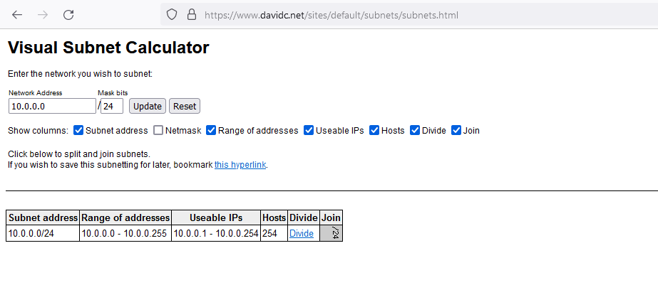

**Then Click on divide in four block of Subnet for getting the IP range**

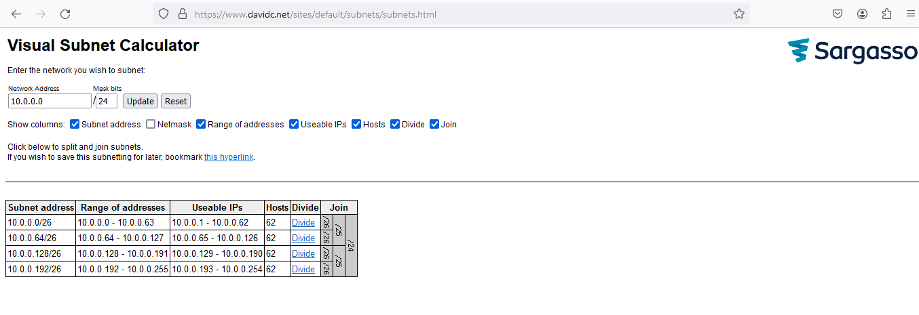

**10.0.0.0/24**

**32-24 = 8**

**2 ^ 8 = 256-2( IP reserved ) 254**

**Example**

**And if you take the subnet range**

**10.0.0.0/26**

**32-26=6**

**2 ^ 6 = 64 -2 ( Reserved) 62**

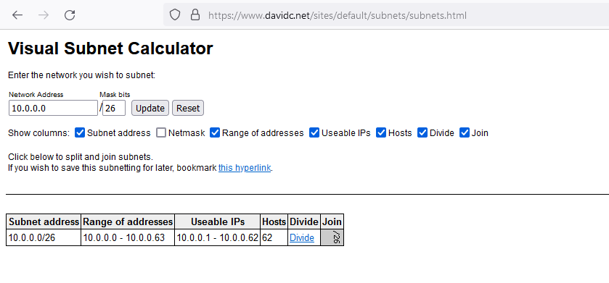

**Once you create the VPC Route Table Automatically created so lets give the our Name RT-Mahesh**

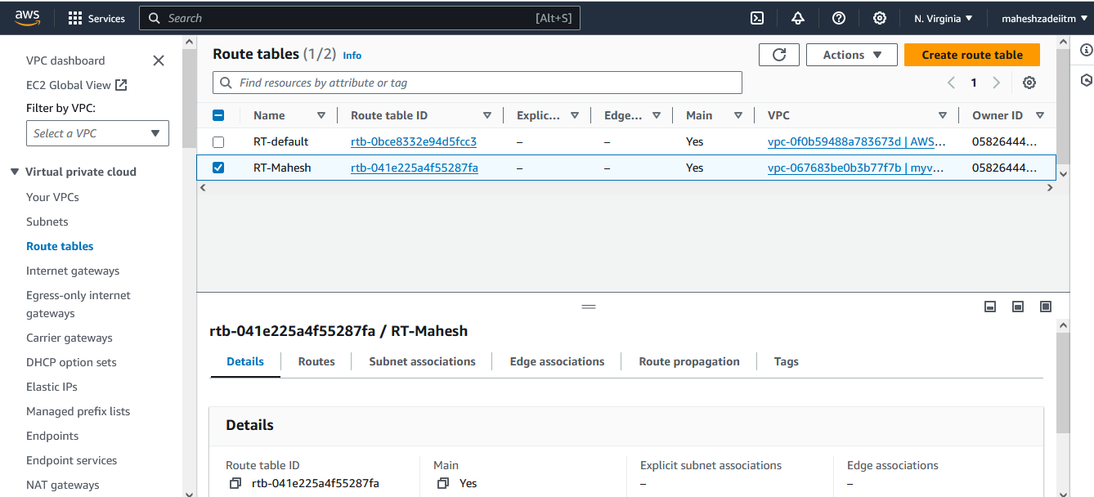

**Once the VPC Created nect jo is to create the subnet**

**Go to subnet**

**Click on create subnet**

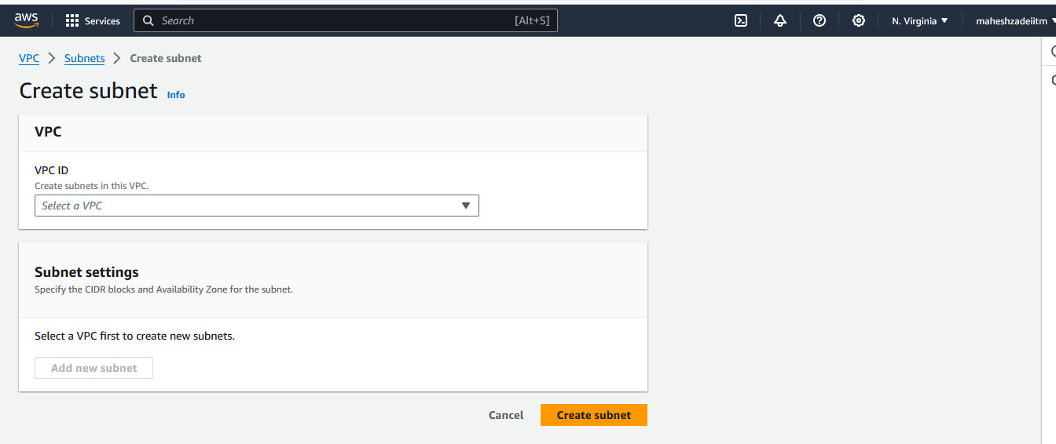

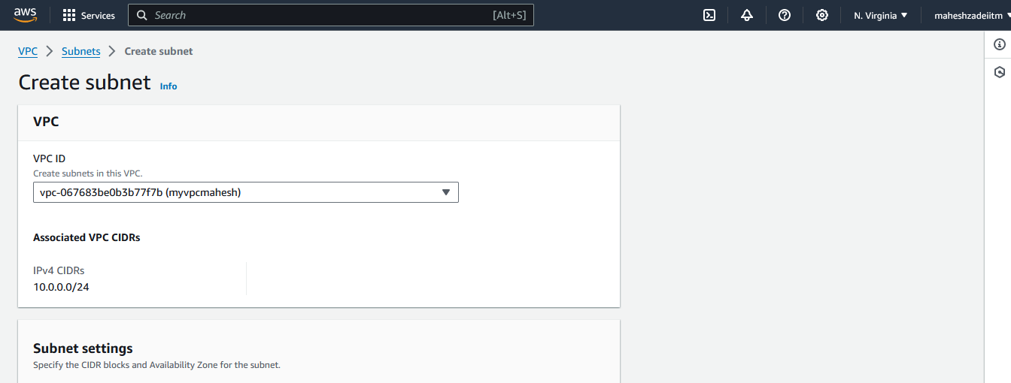

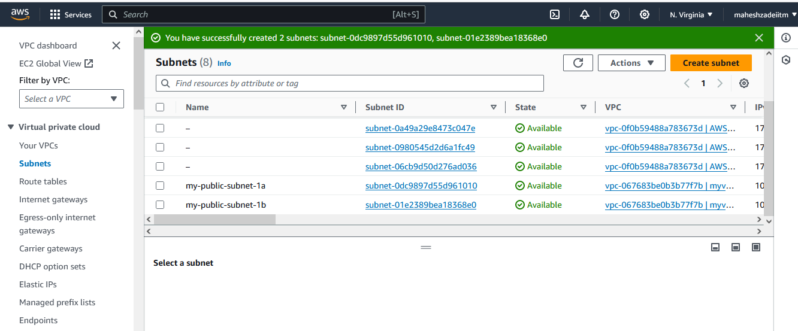

**Select VPC   
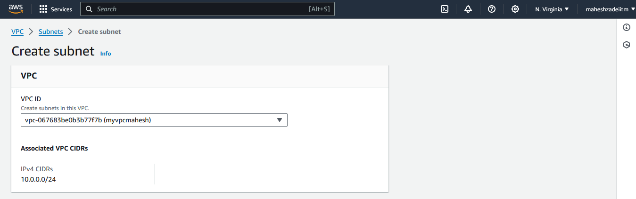**

**Crate 1 public and 1 private subnet**

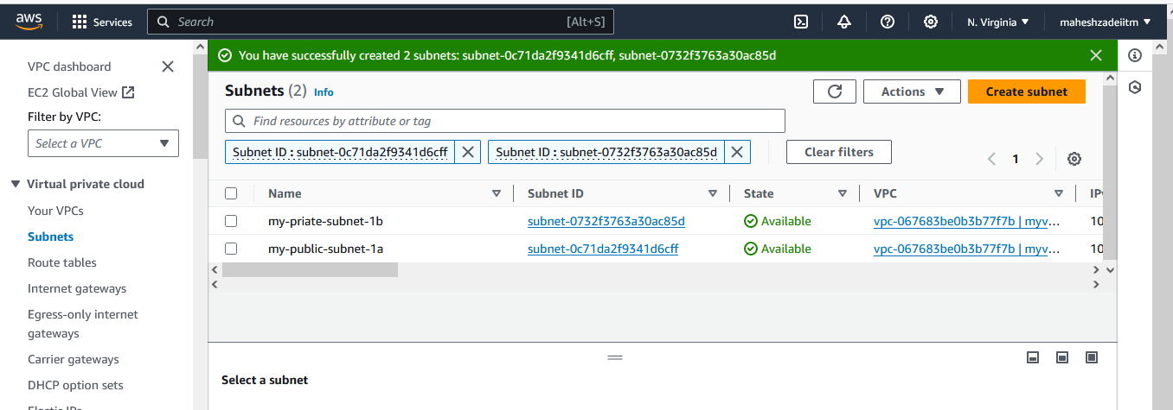

**Select the CIDR rage from Calculator**

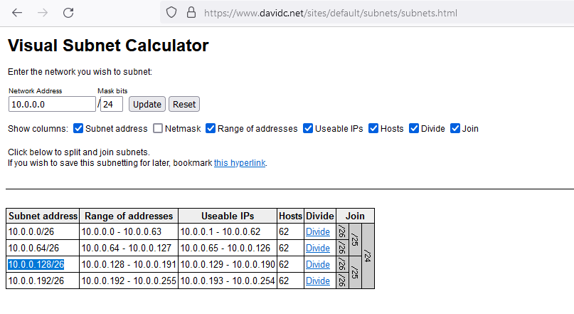

**Private subnet created**

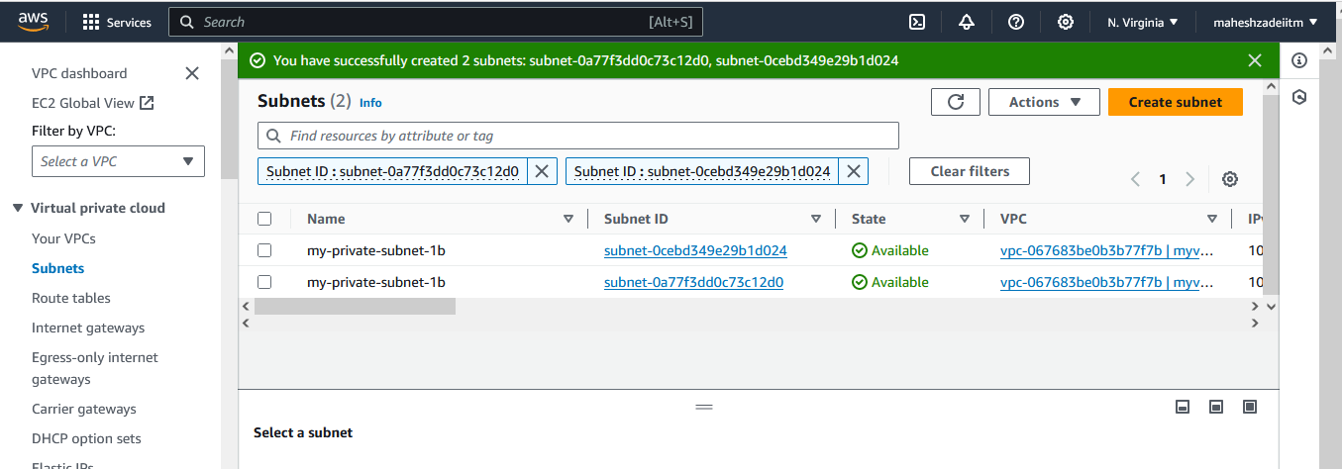

**Now go to Route Tableand make the RT public**

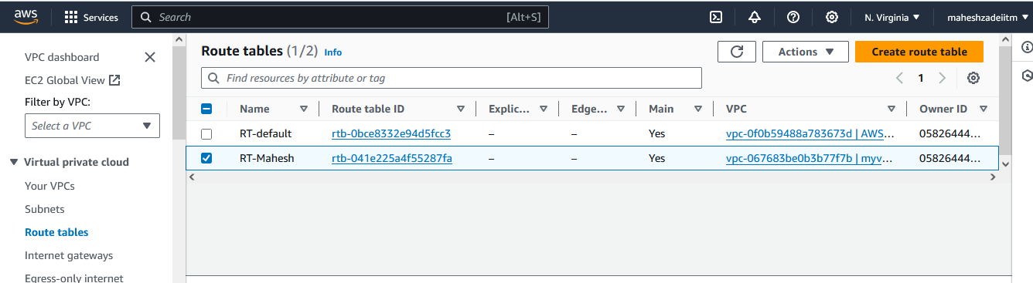

**Go to subnet association and save association**

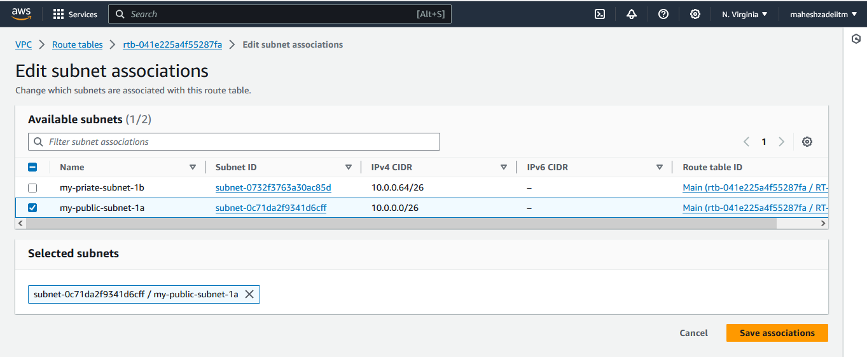

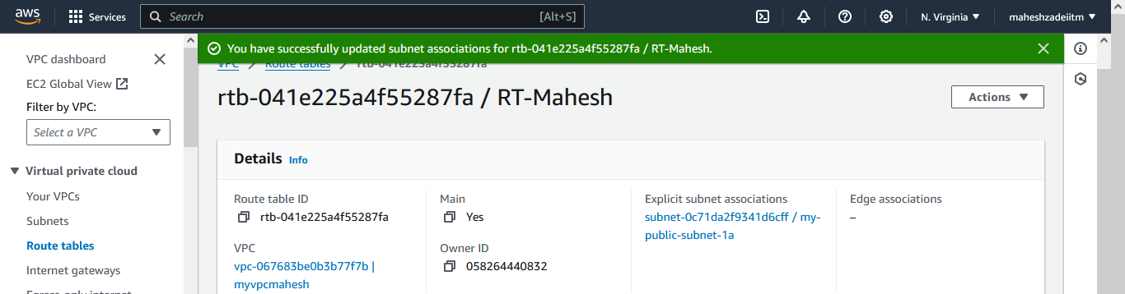

**Now create private RT**

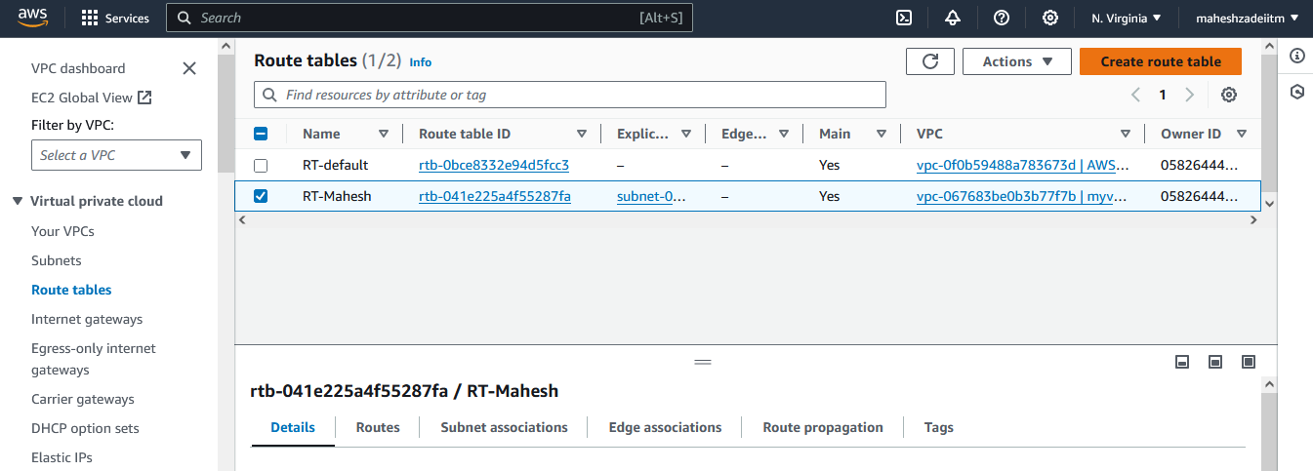

**My private RT created**

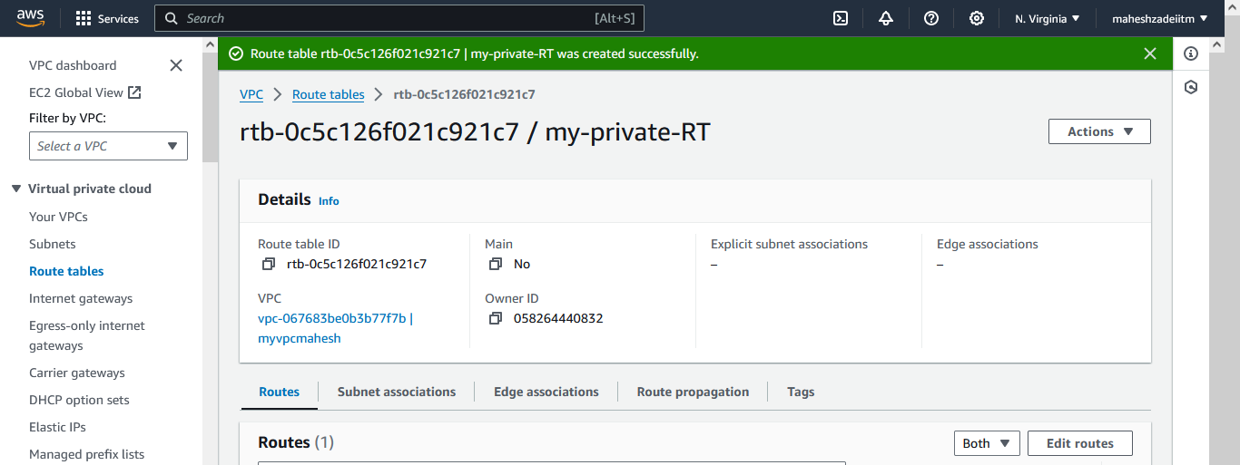

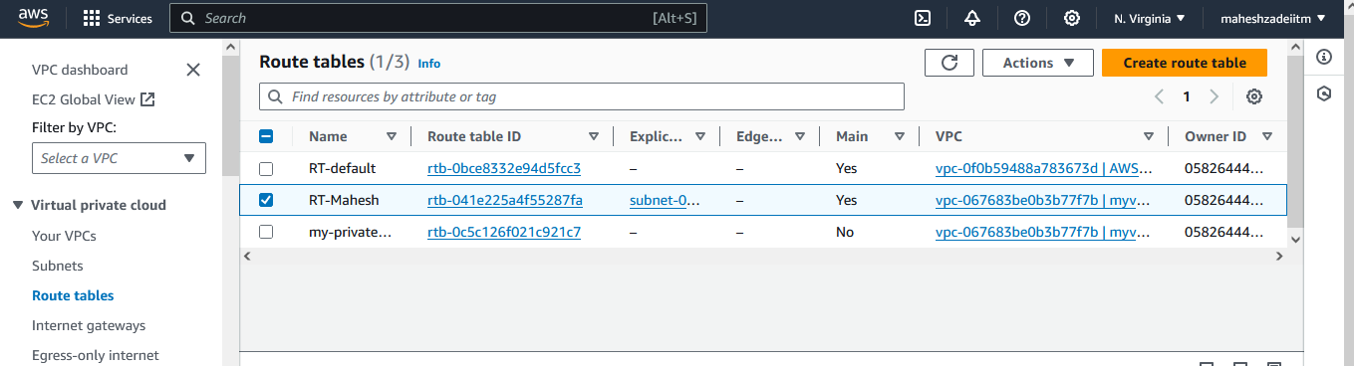

**Associate private subnet private RT and public subnet to public RT**

**Now go to create internet gateway**

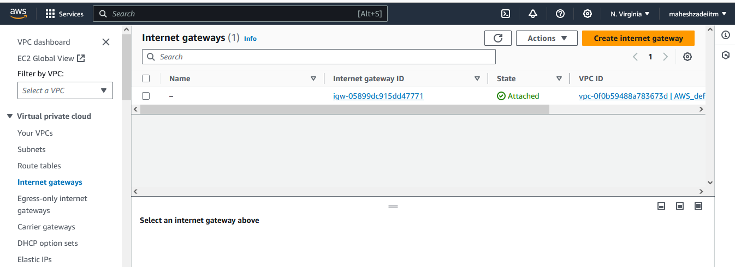

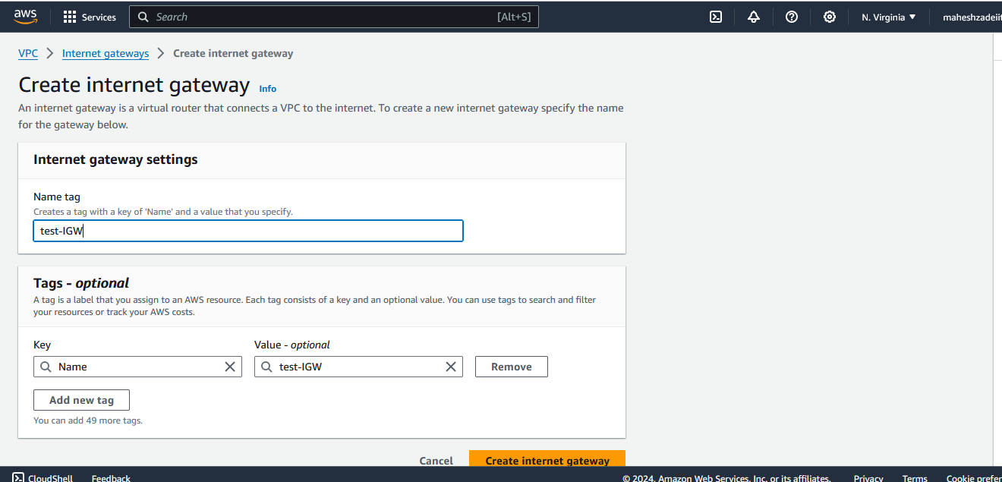

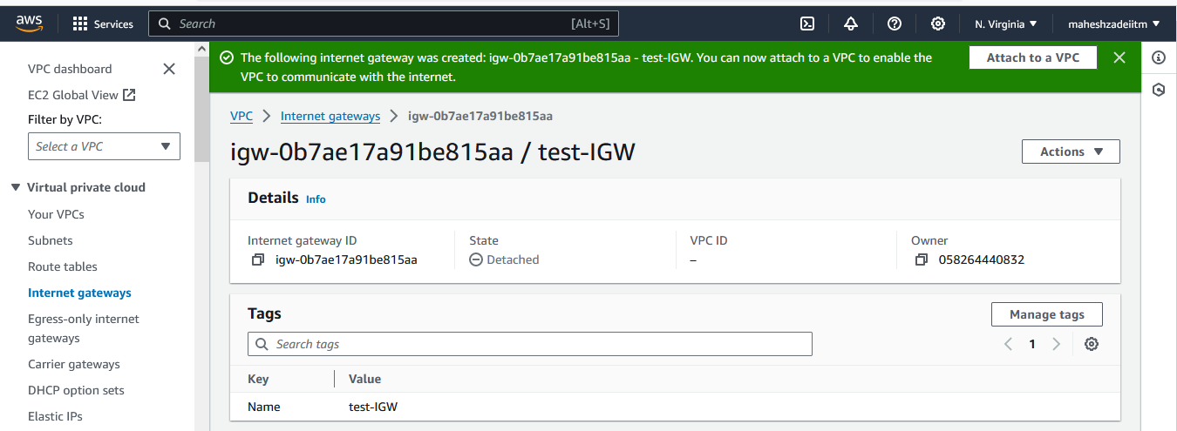

**IGW attach to VPC**

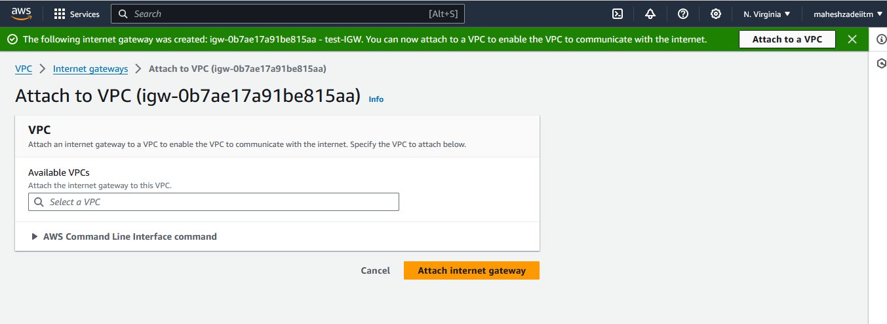

**Click on attach internet gateway**

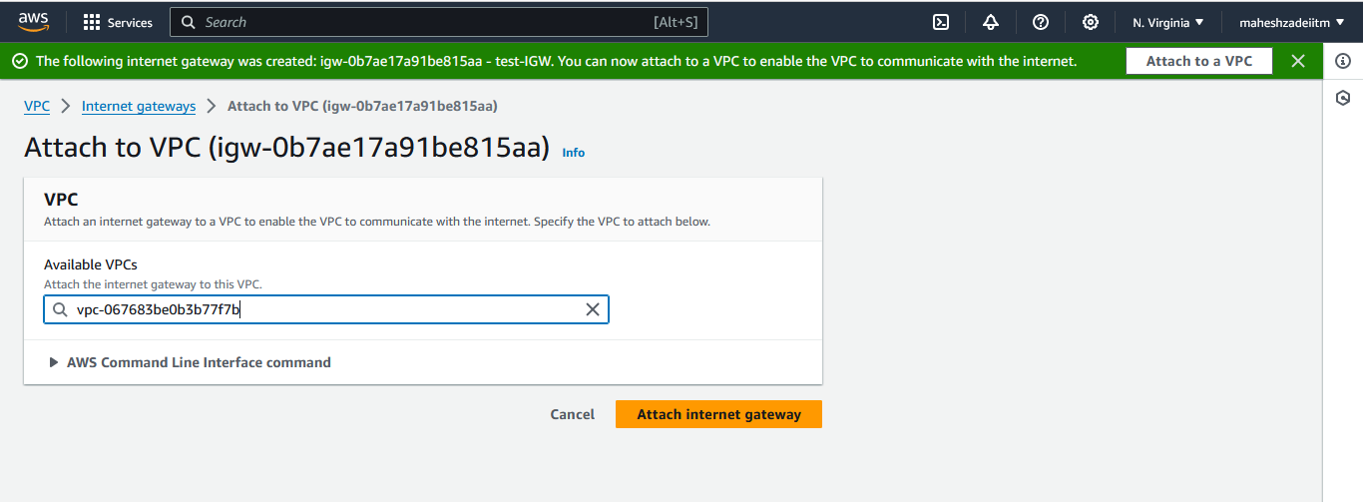

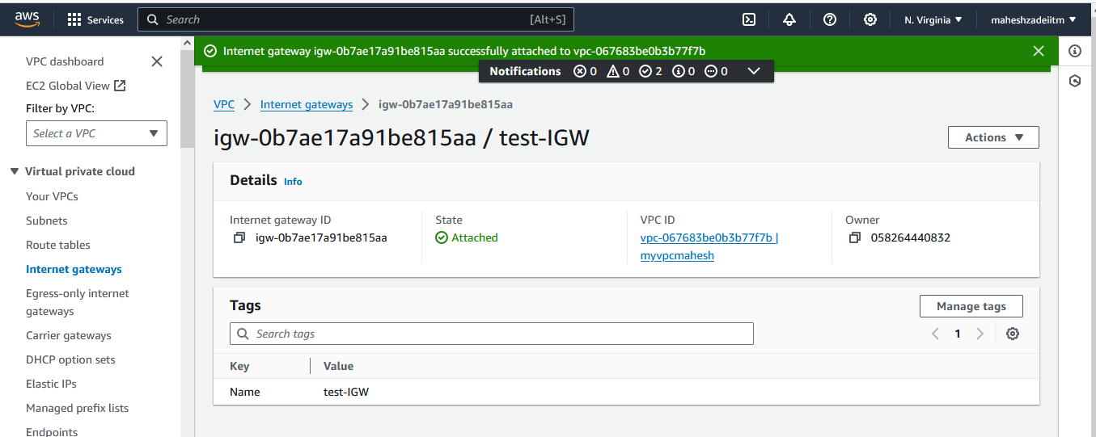

**Now go to Route table**

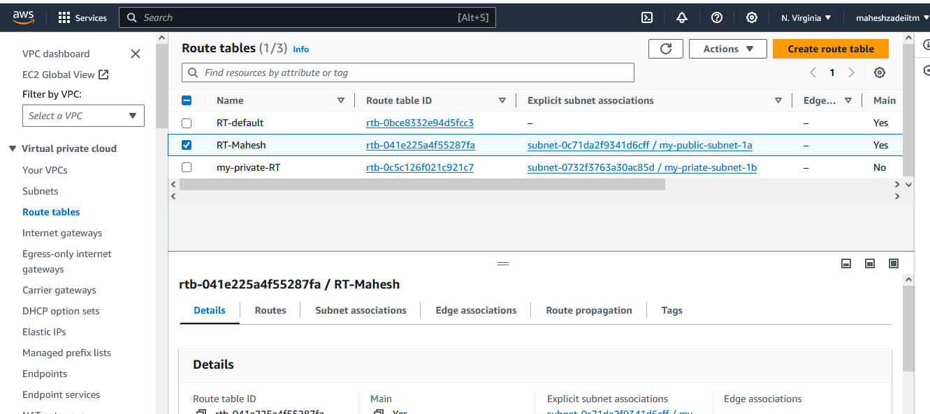

**Click on edit route**

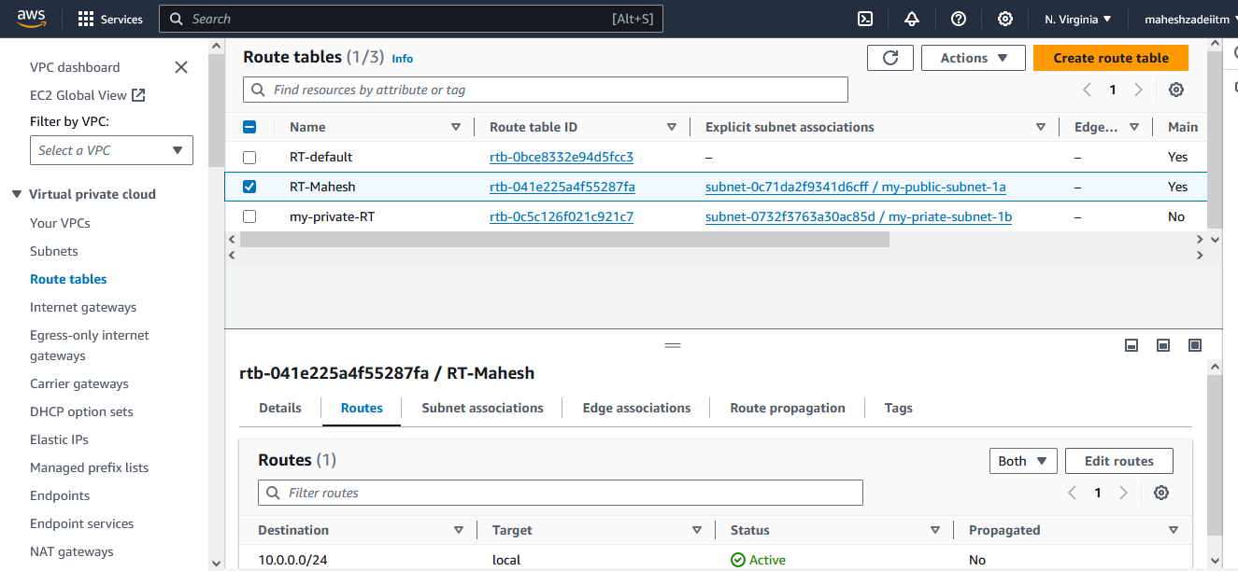

**Select add route and internet gateway**

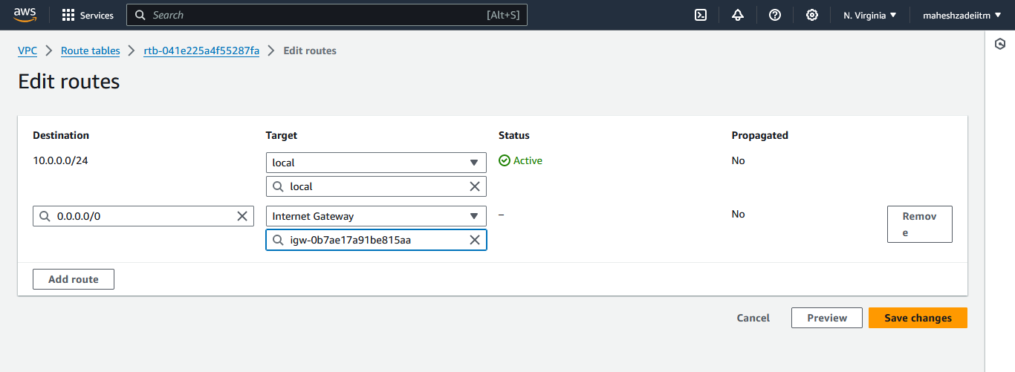

**And save changes**

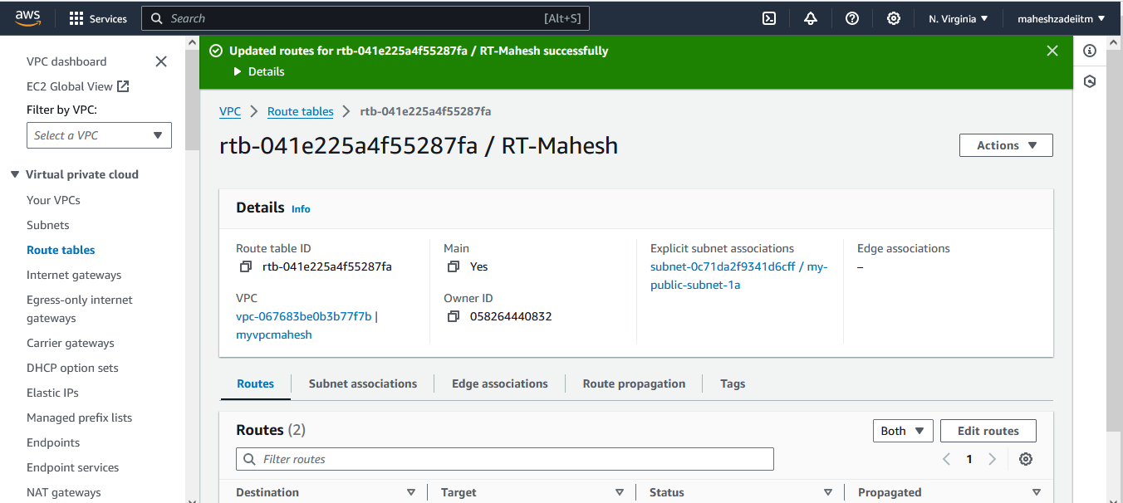

**Why we create the private subnet .**

**If we want access the database in that subnet we can access the database via NAT Gateway**

**So now create the Nat Gate gateway**

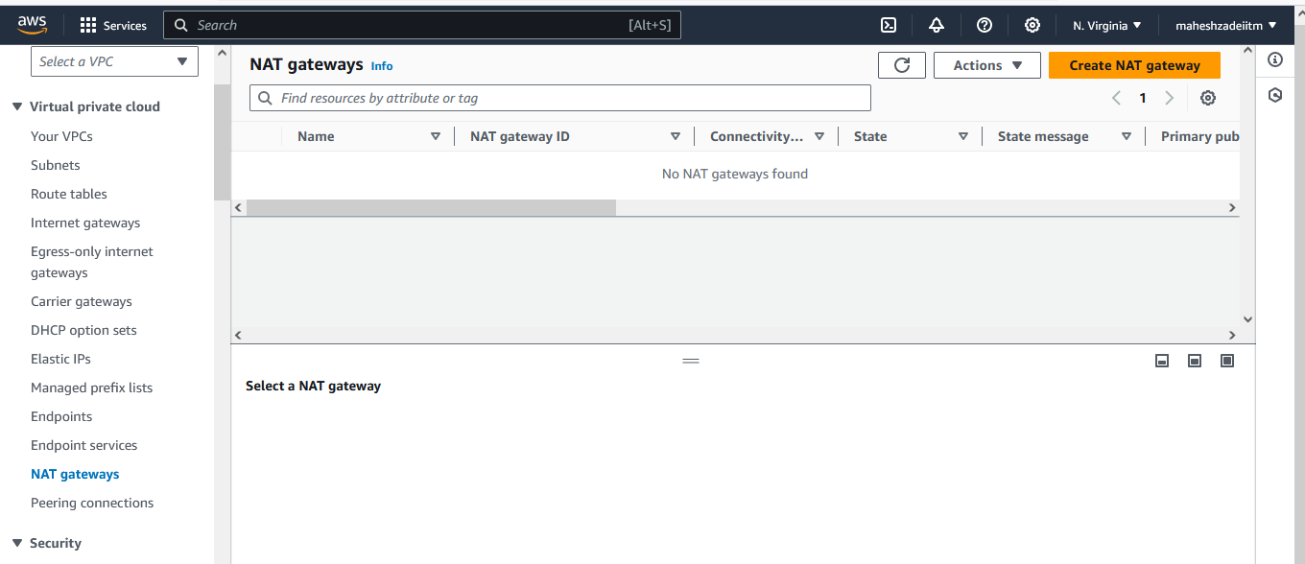

**Create NAT Gateway in public subnet**

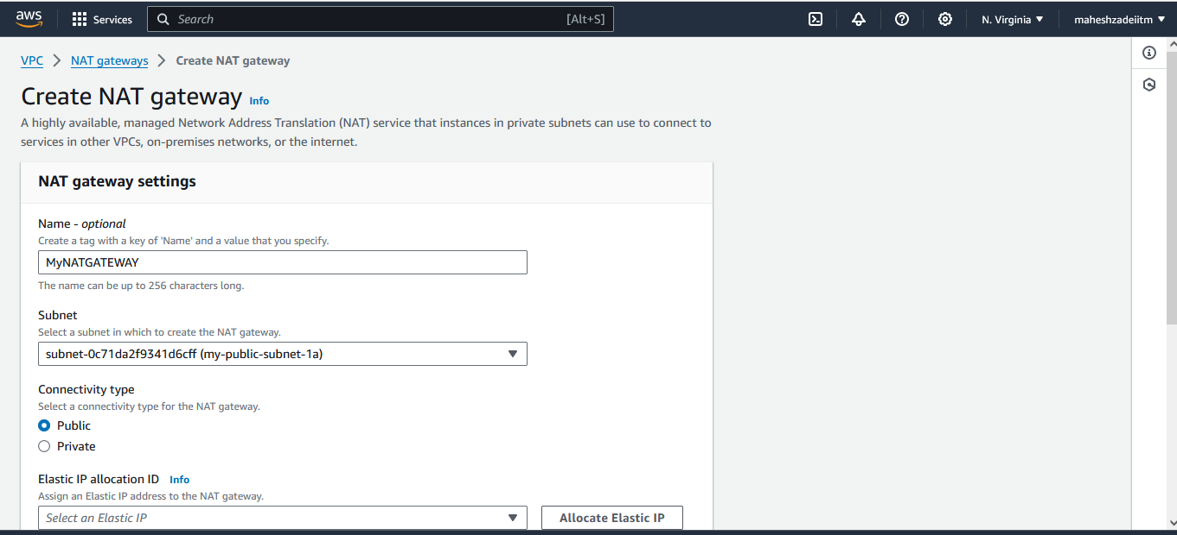

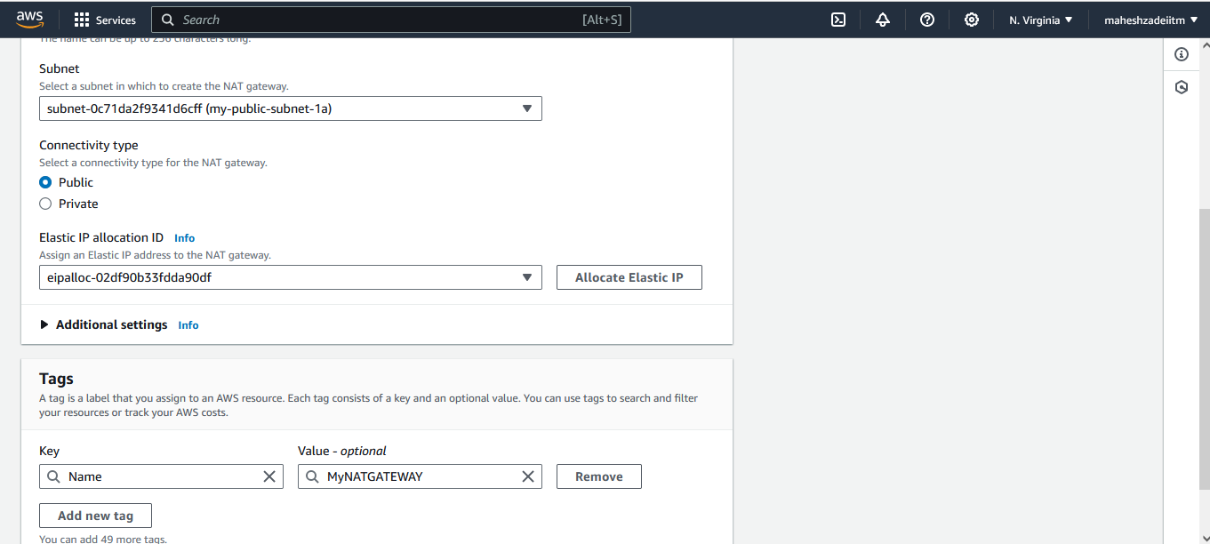

**Click on NAT Gatewqay**

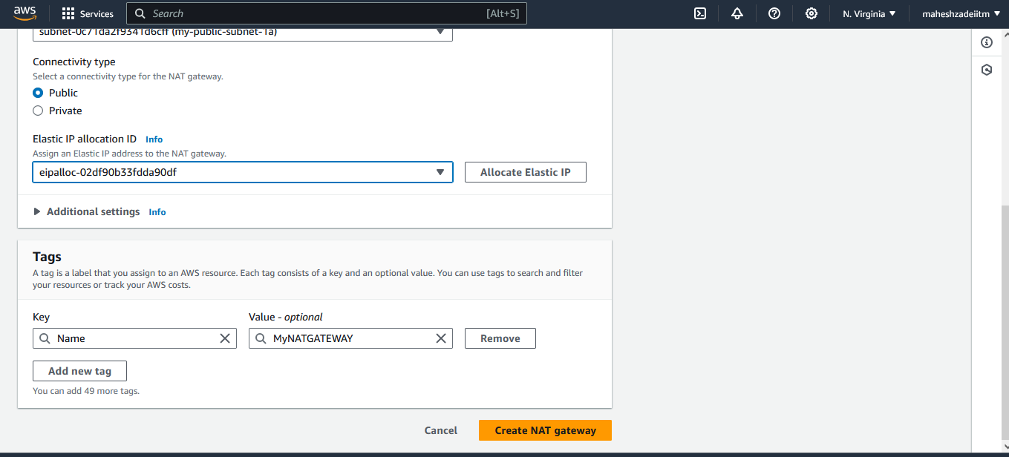

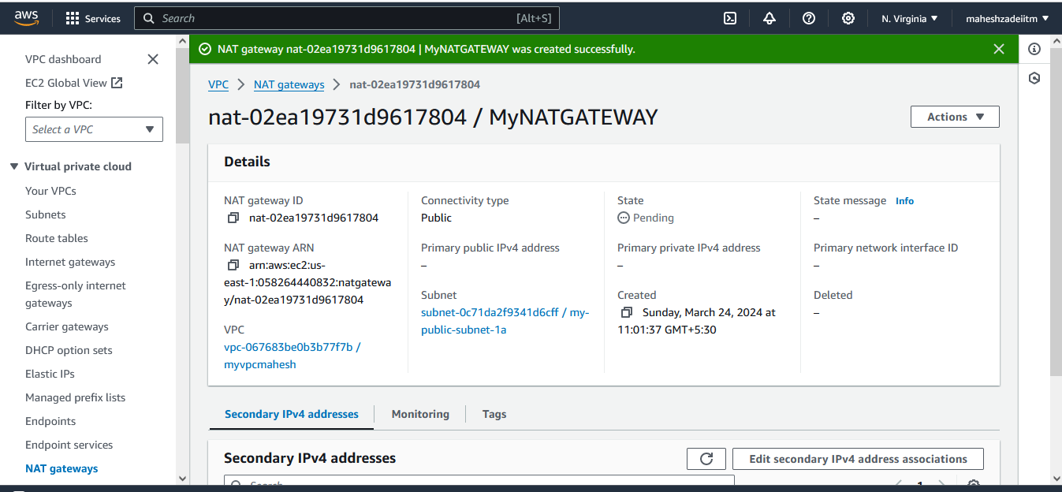

**NATGATEWAY Created**

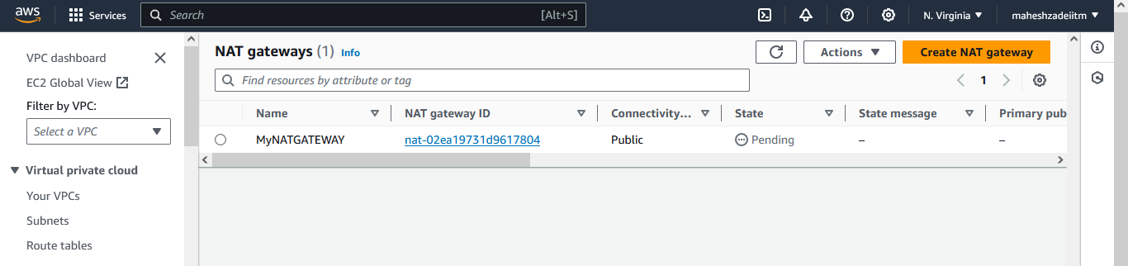

**Wait till available**

**Now NAT gateway os available**

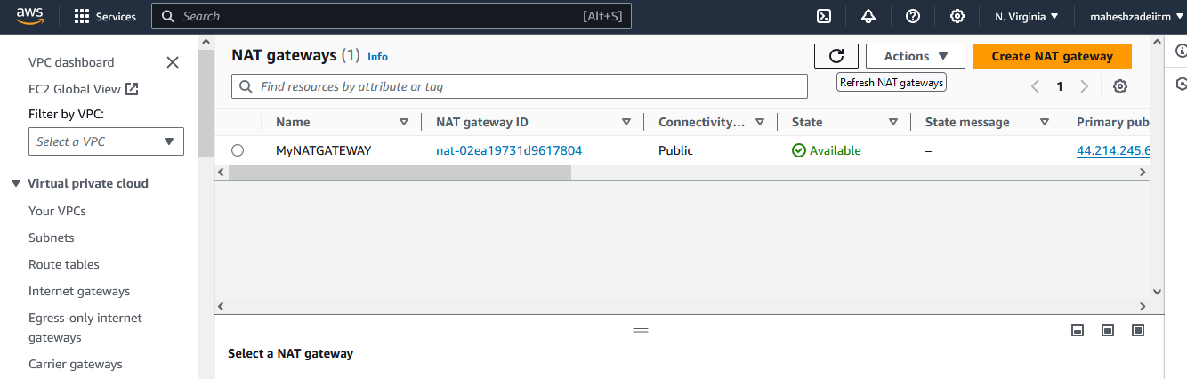

**Now go to private Route Table**

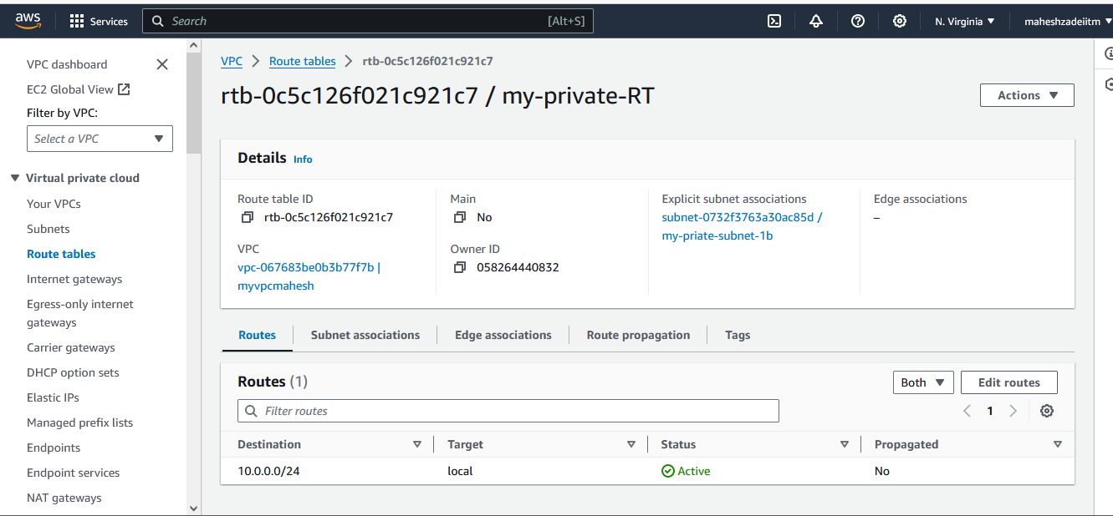

**Edit Route Table**

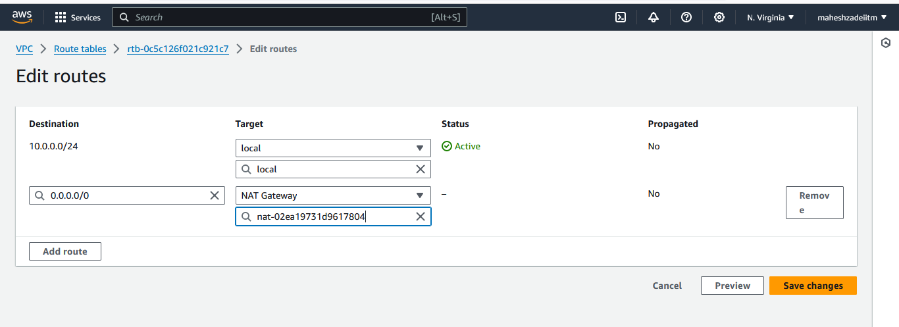

**And Save Changes**

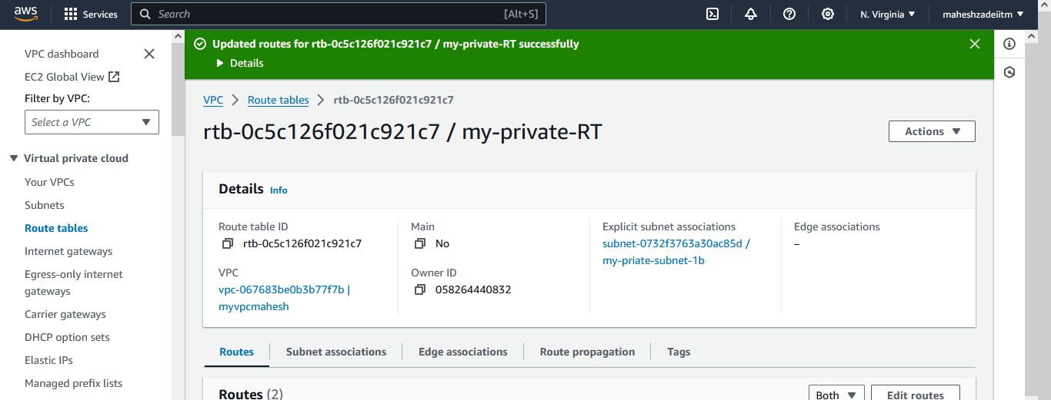

**Now Go to EC 2 and launch EC 2 Windows Machine**

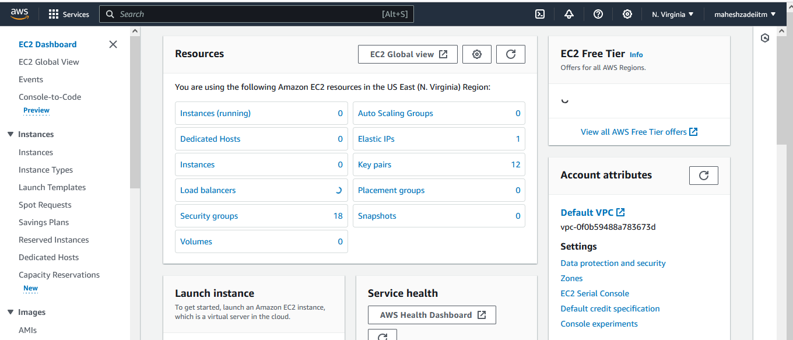

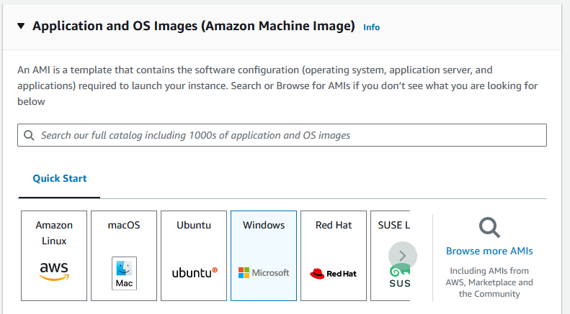

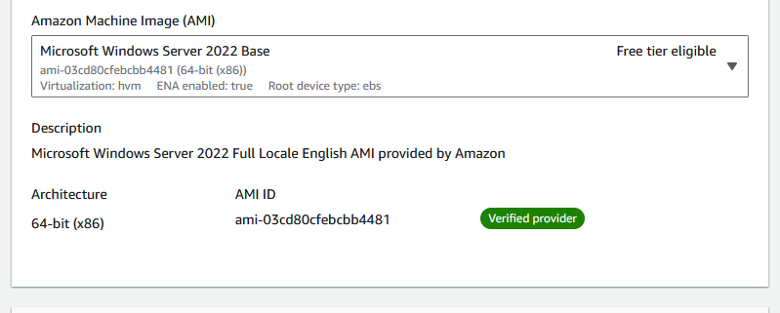

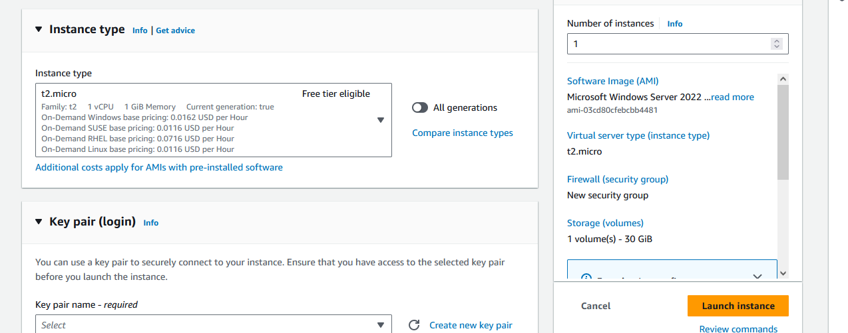

**Download Keypair in N Virginia**

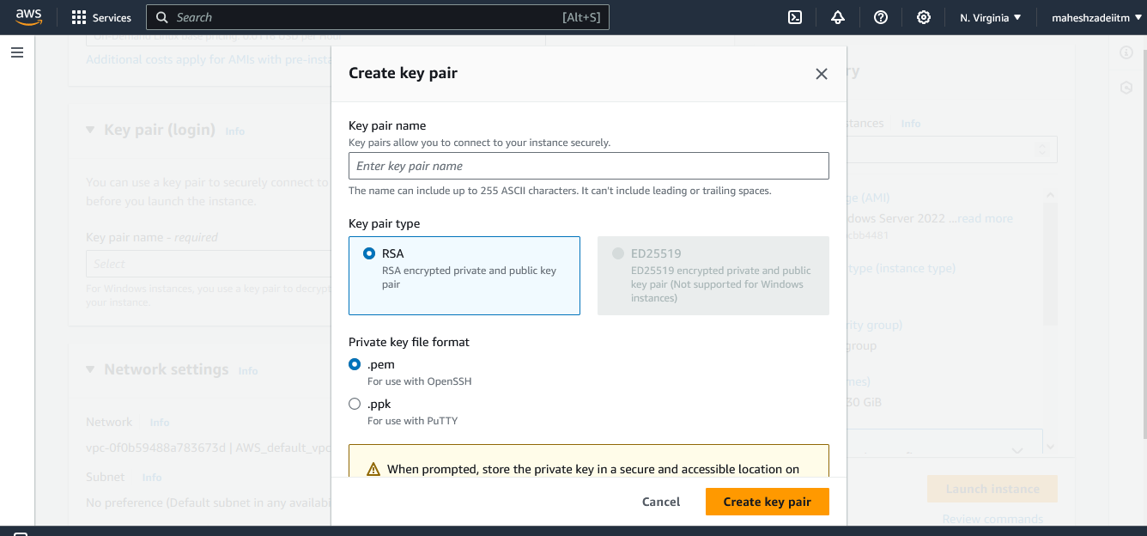

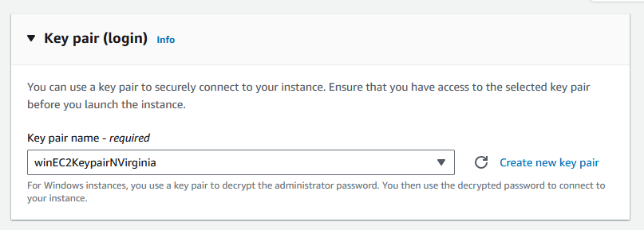

**Edite network setting**

**Select my VPC / public Subnet and Click on auto assigned public IP**

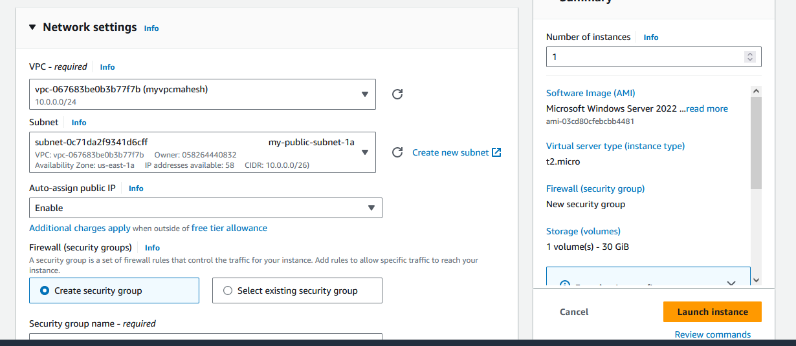

**Security group can be default**



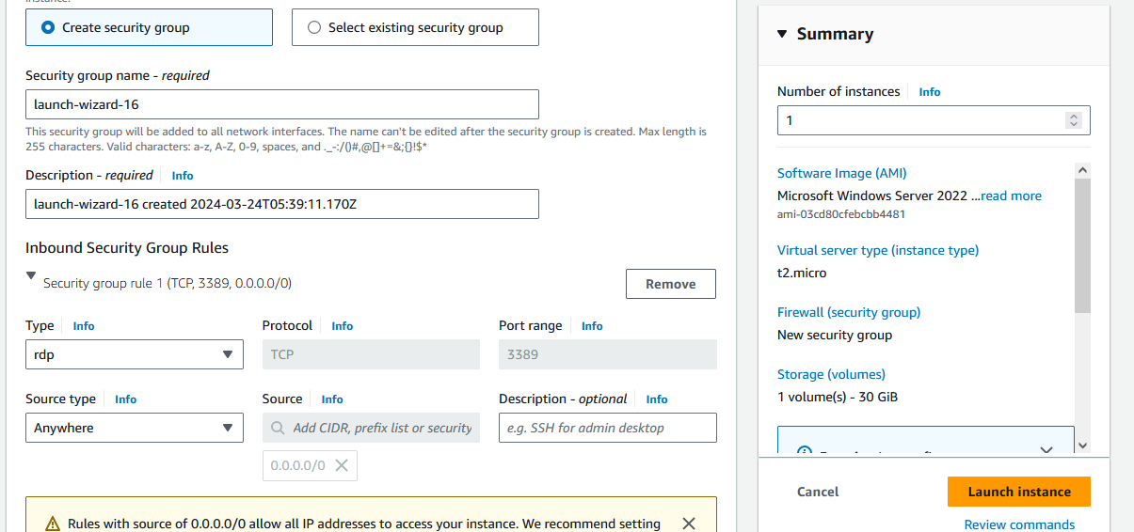

**Keep the setting as it is and launch instance**

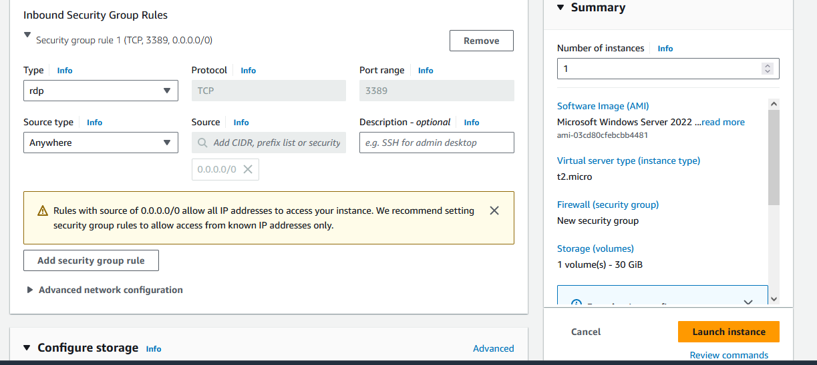

**Storage 30 GB**

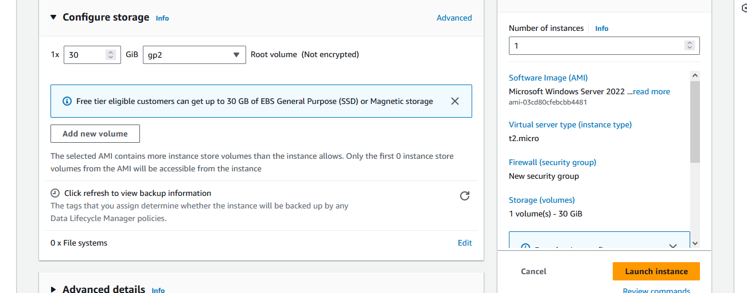

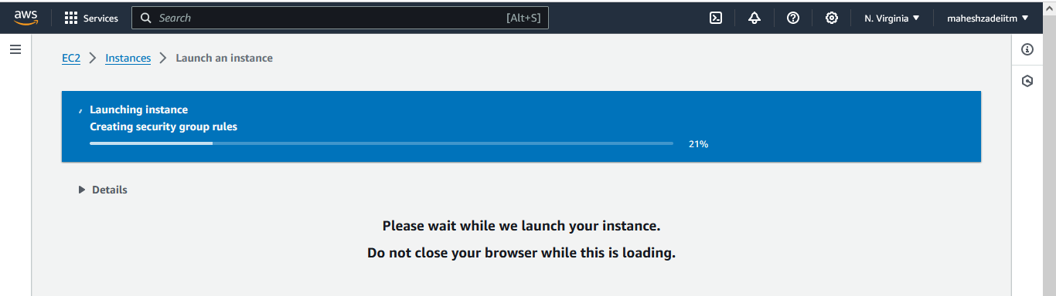

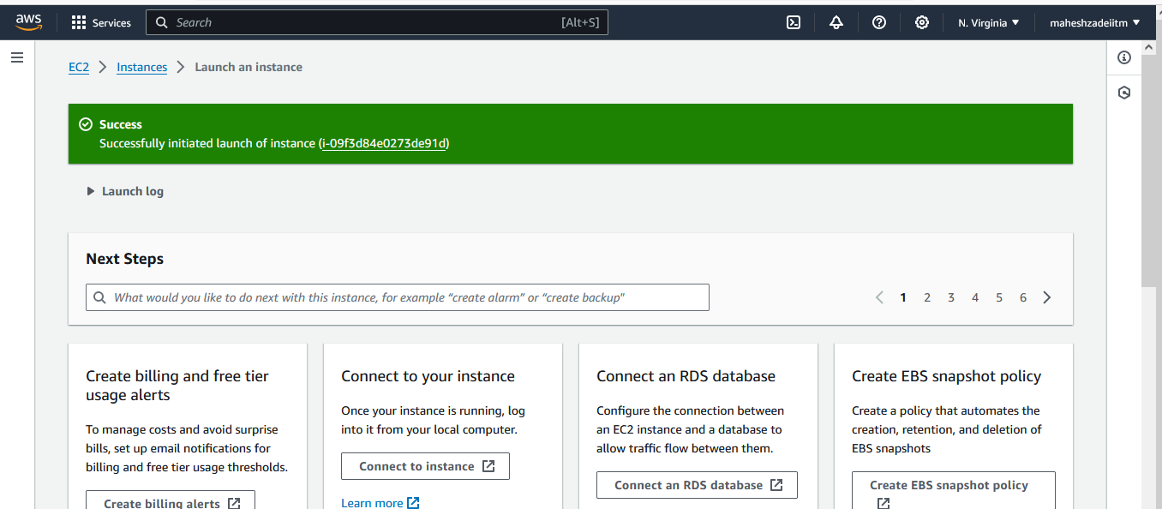

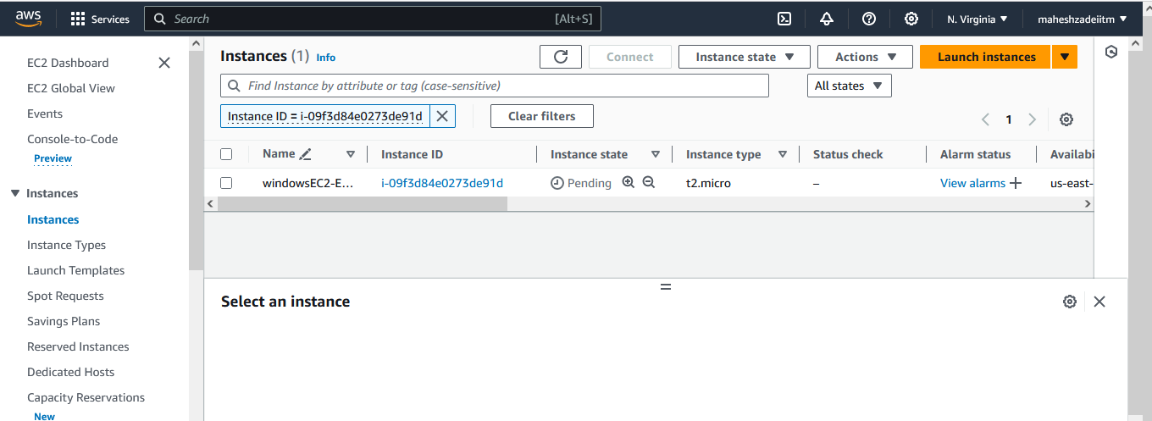

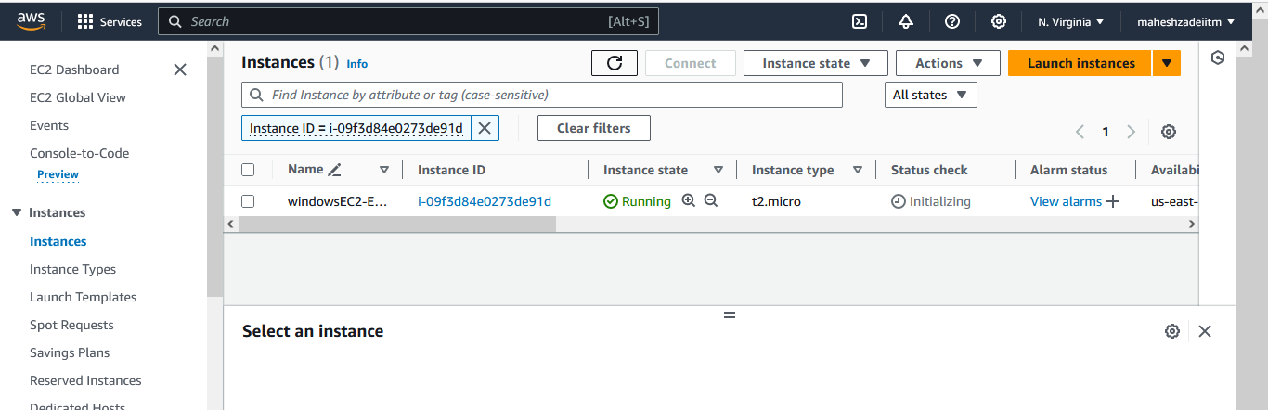

**Go to action and click on connect**

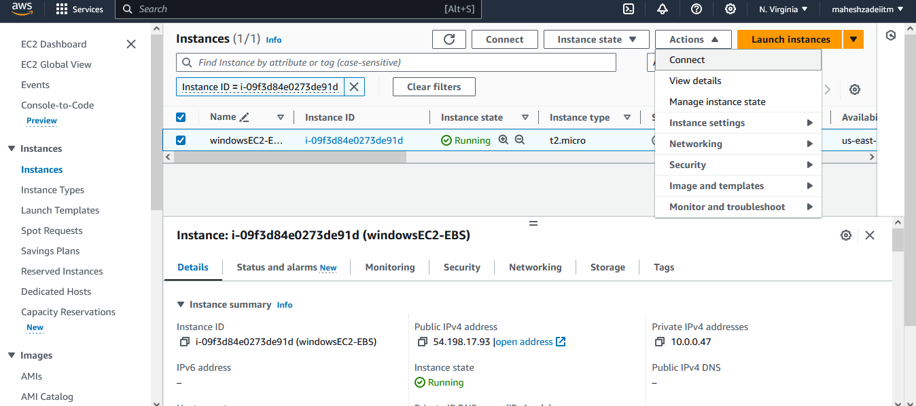

**Click on RDP Client**

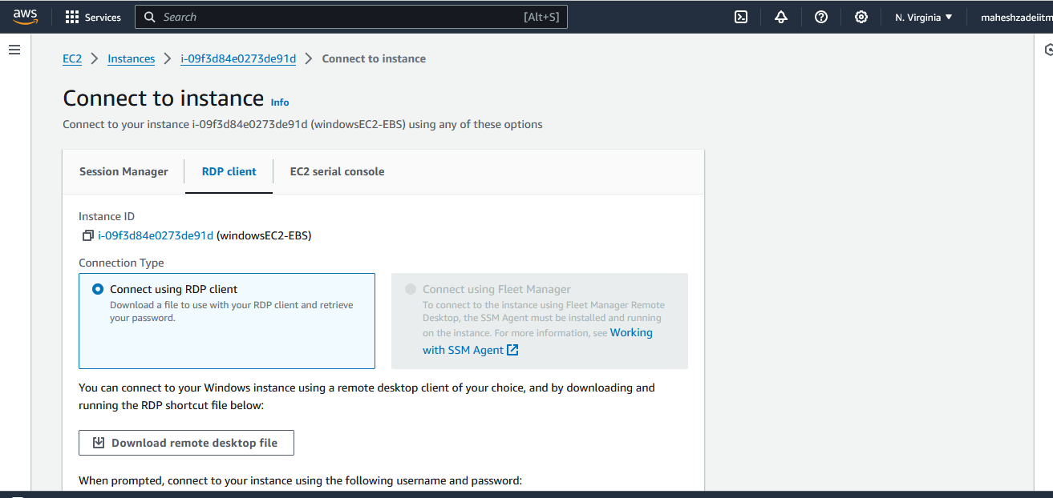

**Download remoate desktop file**

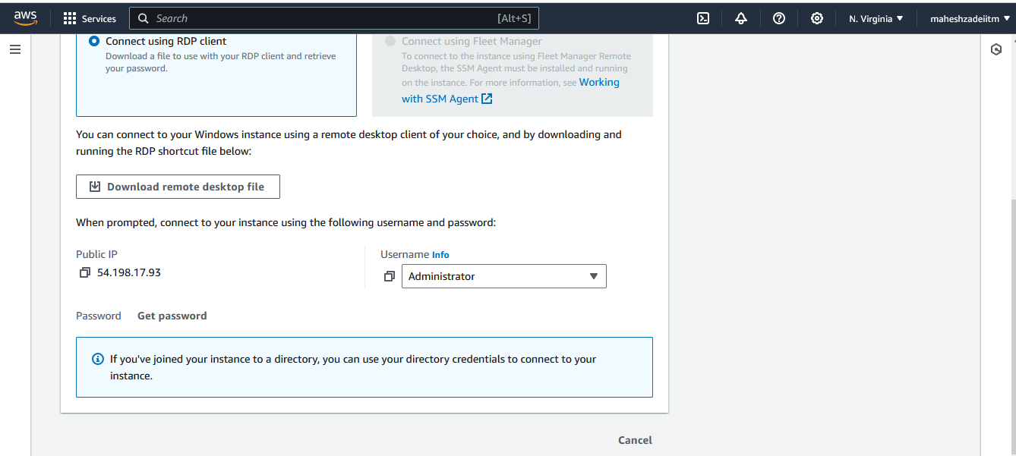

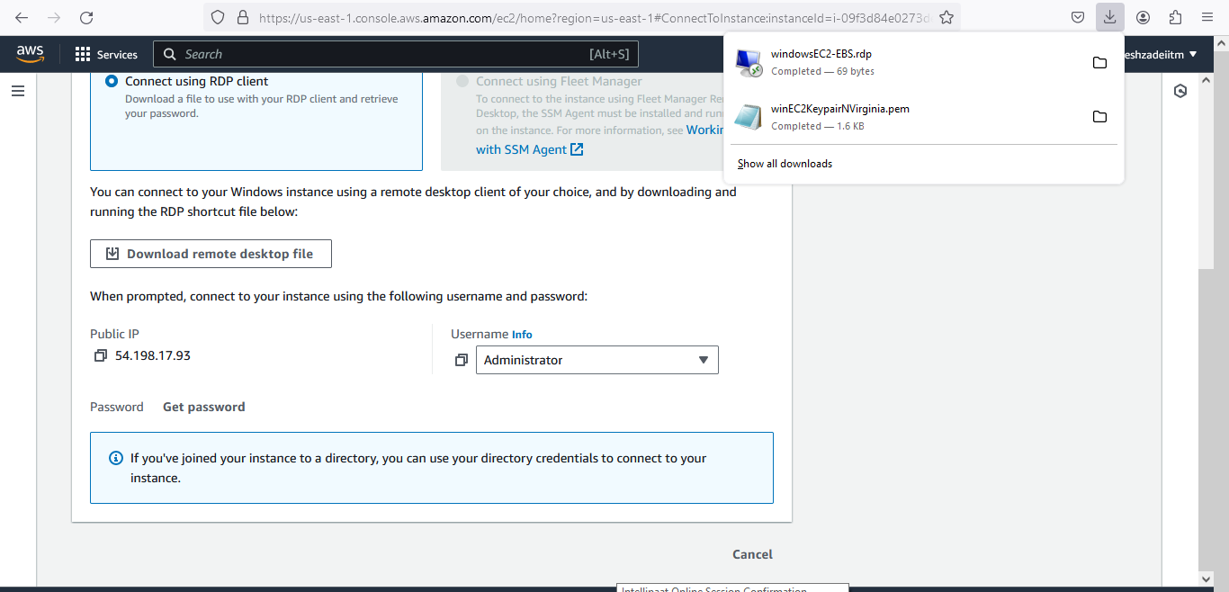

**Click on gate password**

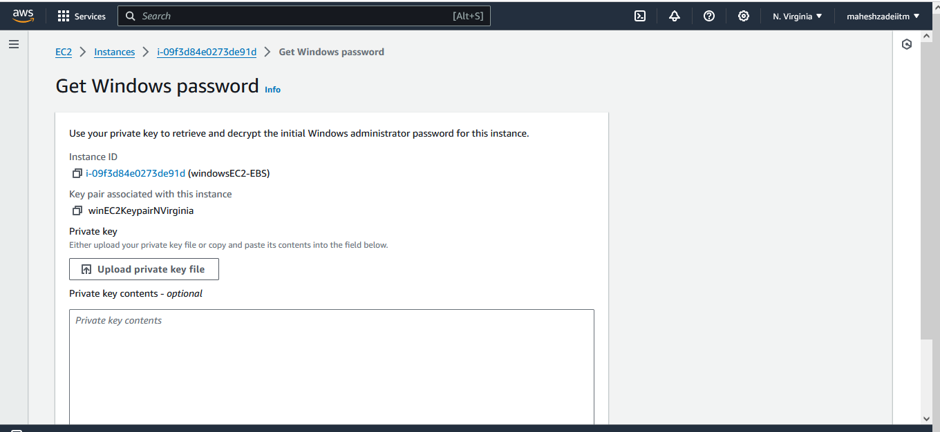

**Upload private key**

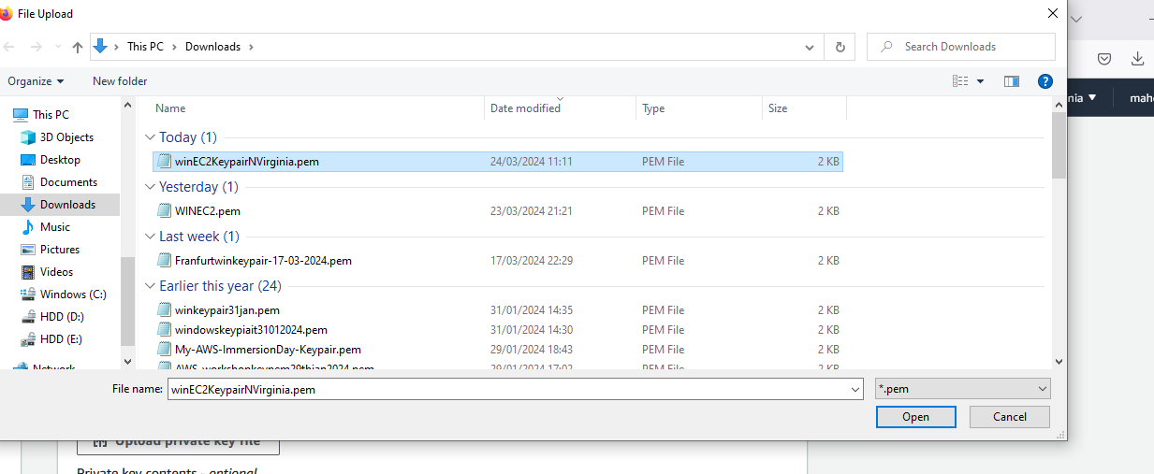

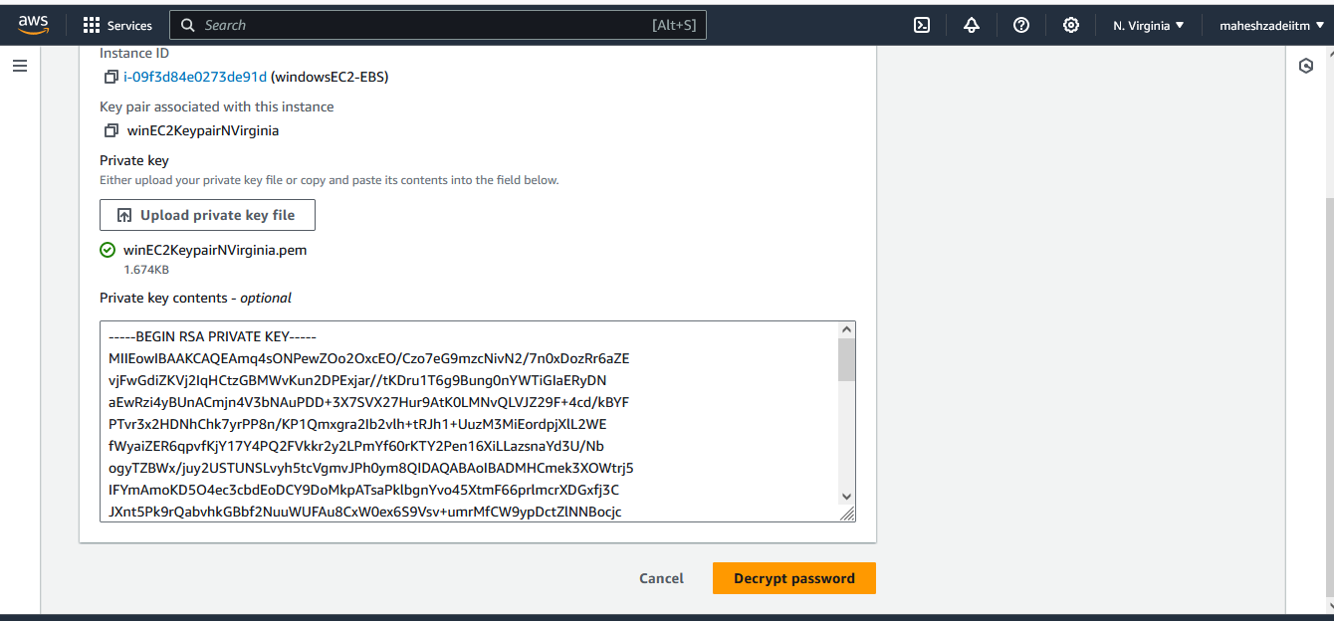

**Click on decript password**



**Copy password and user name**

**Username :** Administrator

**Password :** Wdzav)Bv2slh.WR8)n?HZhce*68c477t

Click on Remote desktop file which is download

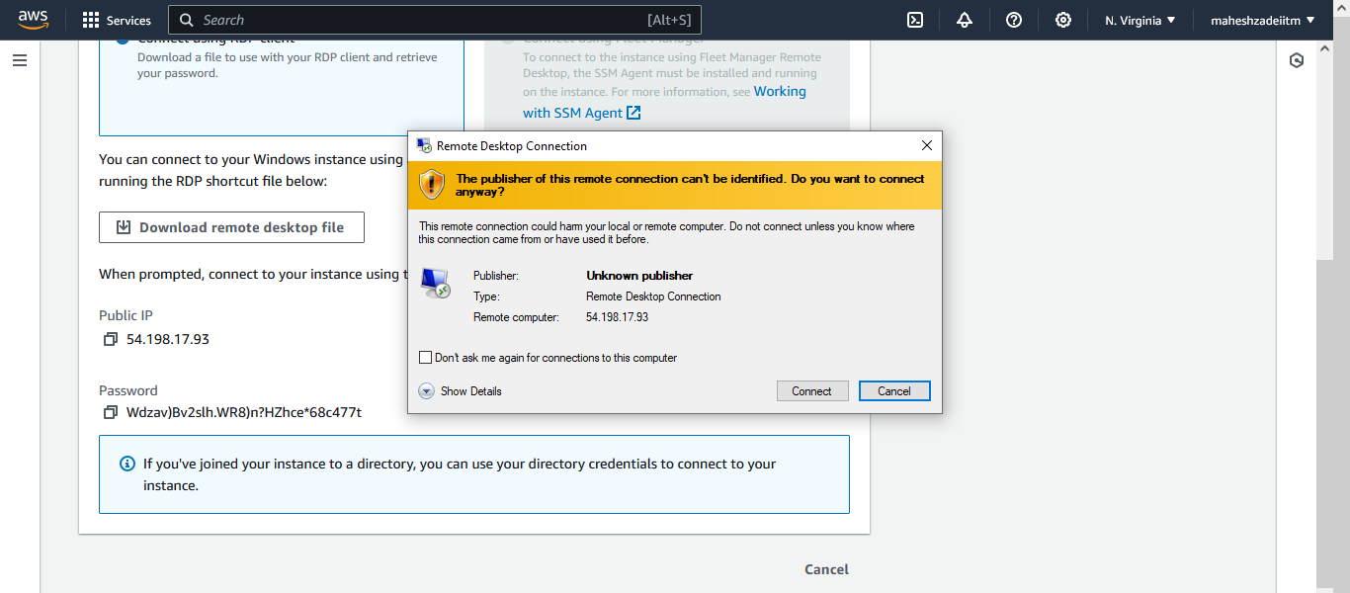

**And click on connect**

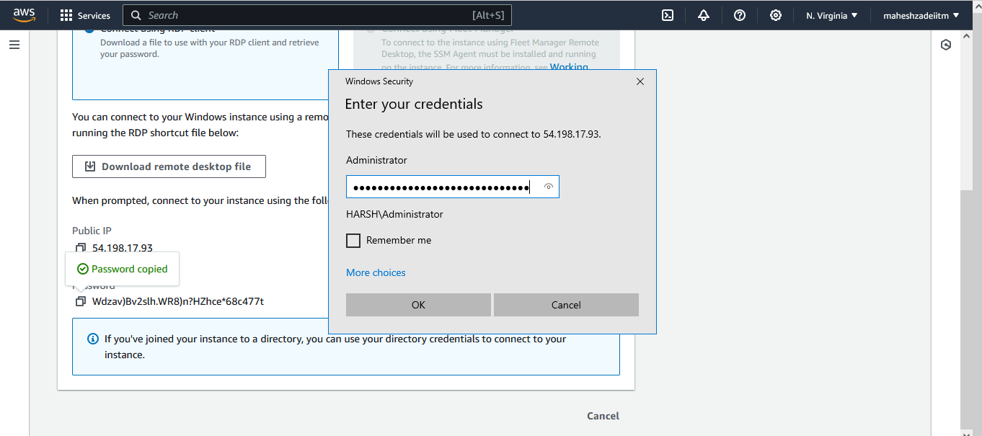

**Copy password**

**And click on ok**

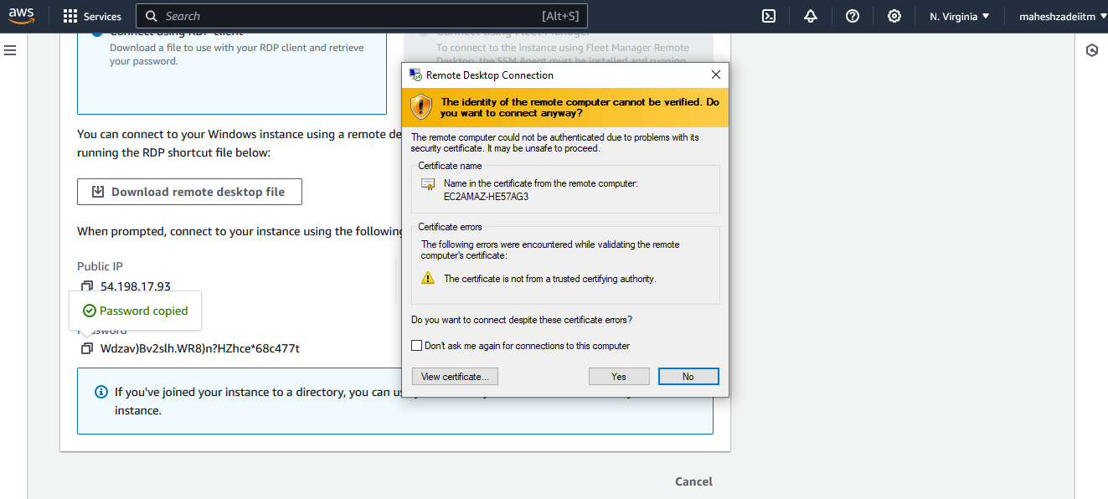

**Connected to Windows EC2 insatnce**

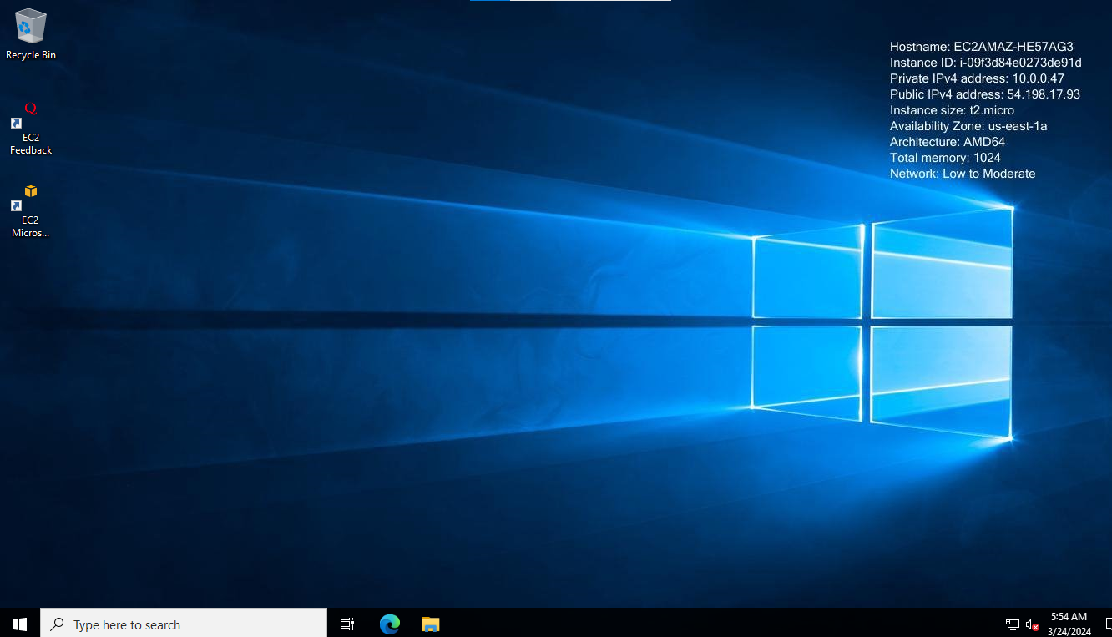

**Now Change the default password of administrator**

**Now go to computer management**

**Go to user and groups and then click on users**

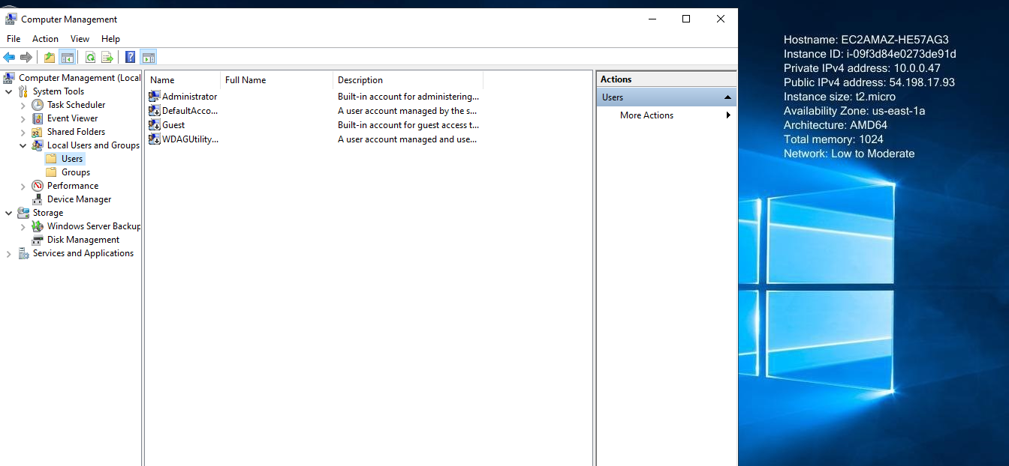

**Right clik on administrator**

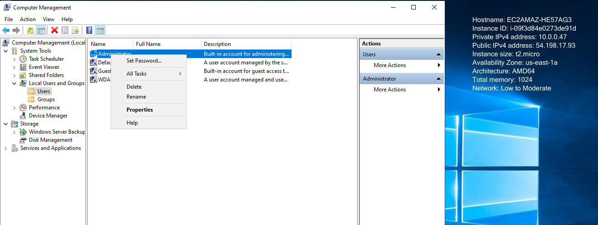

**Click on set password**

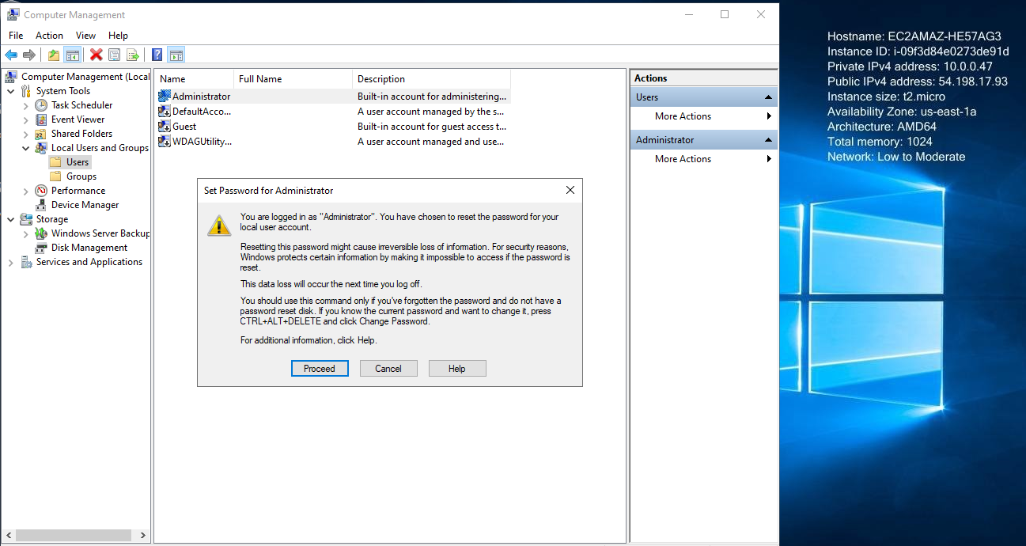

**Proceeed**

**Enetr New and reneter password**

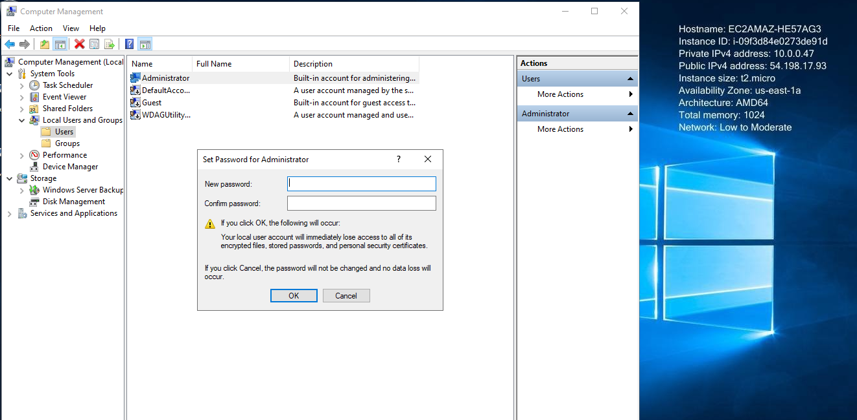

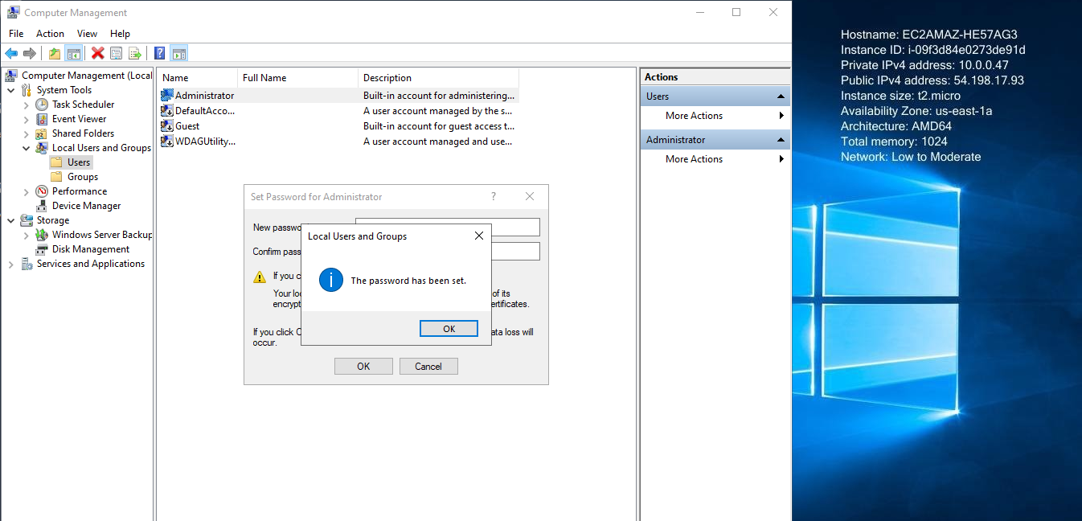

**India@1234 is a password**

**And then click on ok**



**Now again try to connect with new password**

**Go to AWS Console**

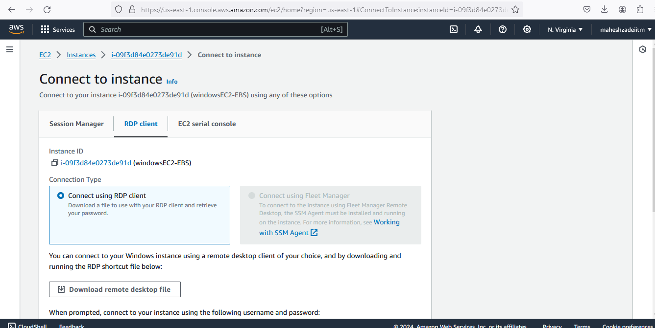

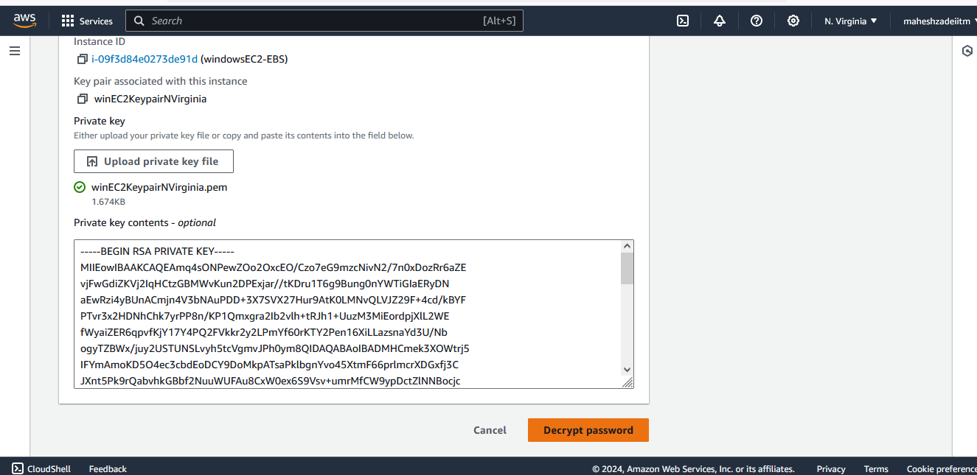

**Decrip password again**

**Copy the password and paste in**

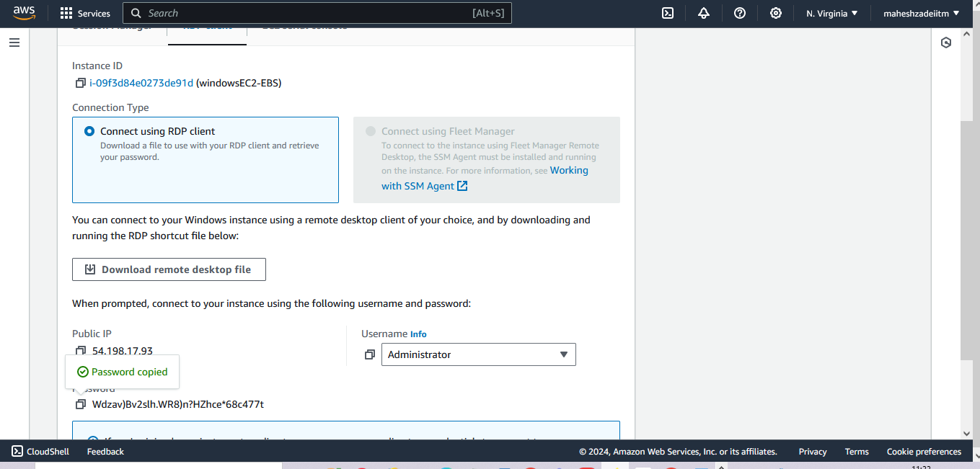

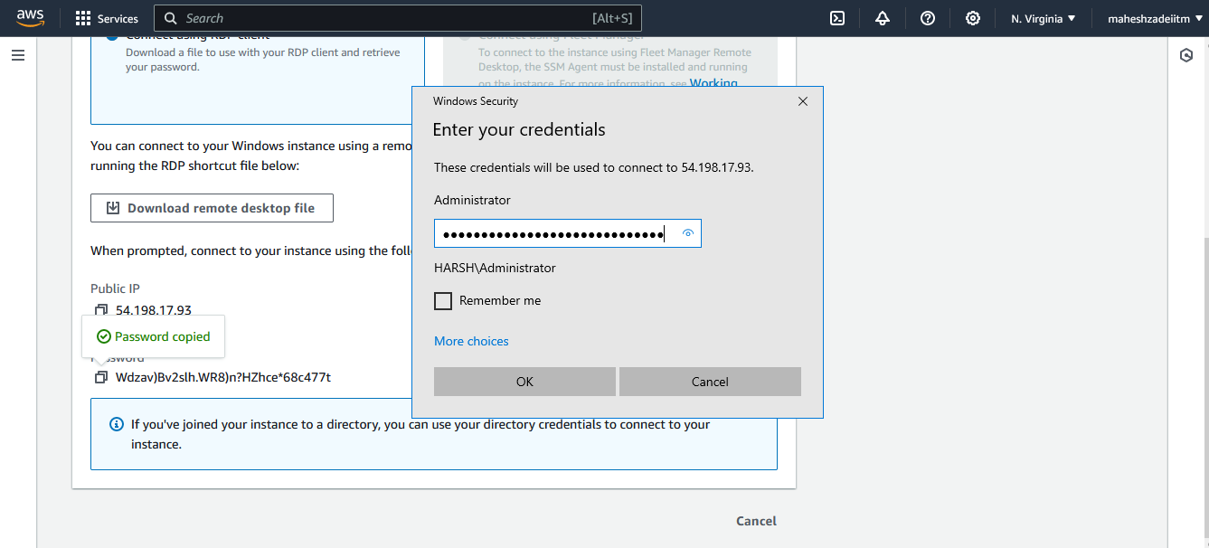

**Not connecting after changing the password**

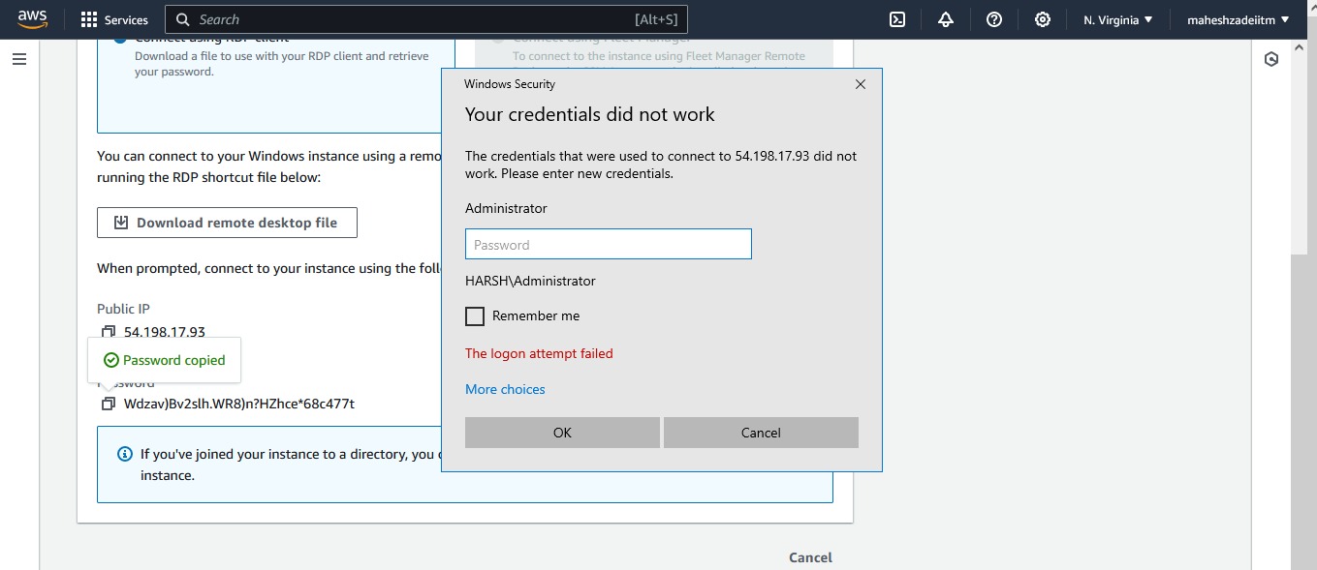

**Put the password India@1234 which is changed**

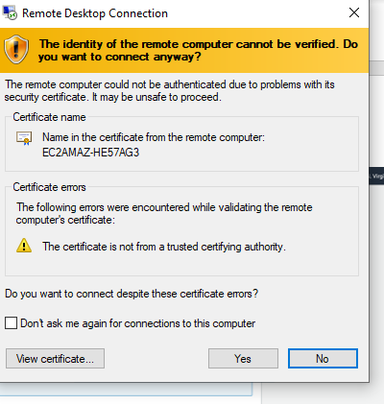

**Connect ing**

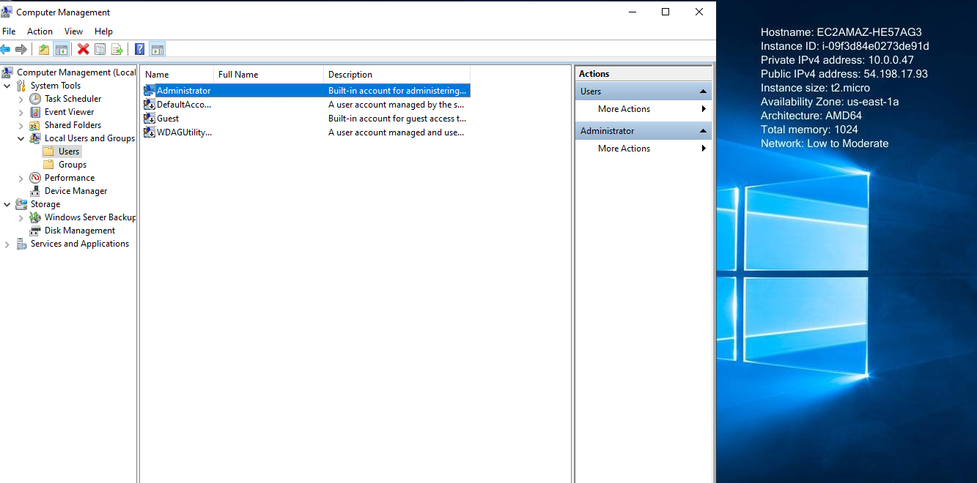

**Connected**

**Now Create the new user for login ( As multiple use will log in the account )**

**Go to computer Management**

**Then user and Right to create the new user on Right Side and fill the information**

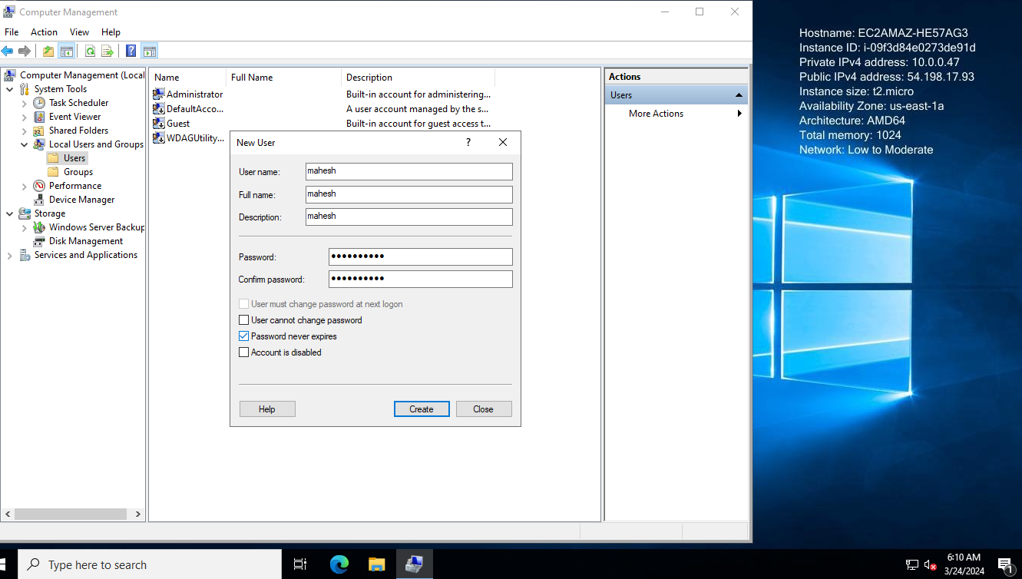

**Now go to groups and give the permission to user mahesh**

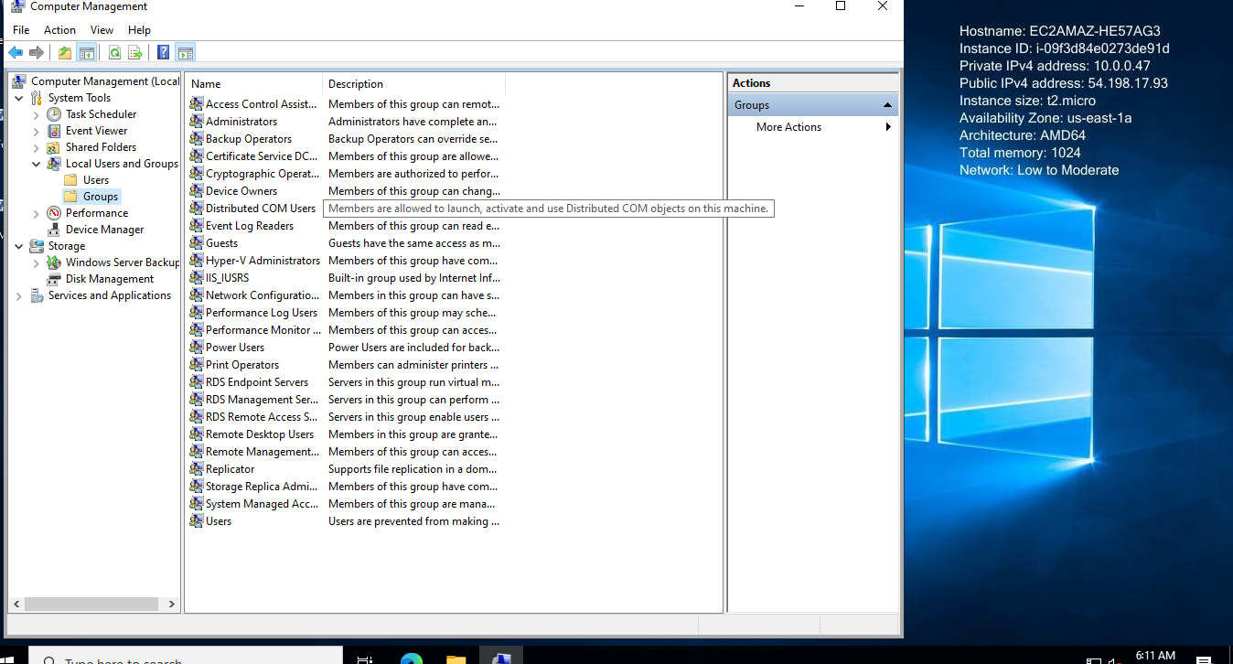

**Select administrator group and Right Click**

**Then click on add**

**Select user**

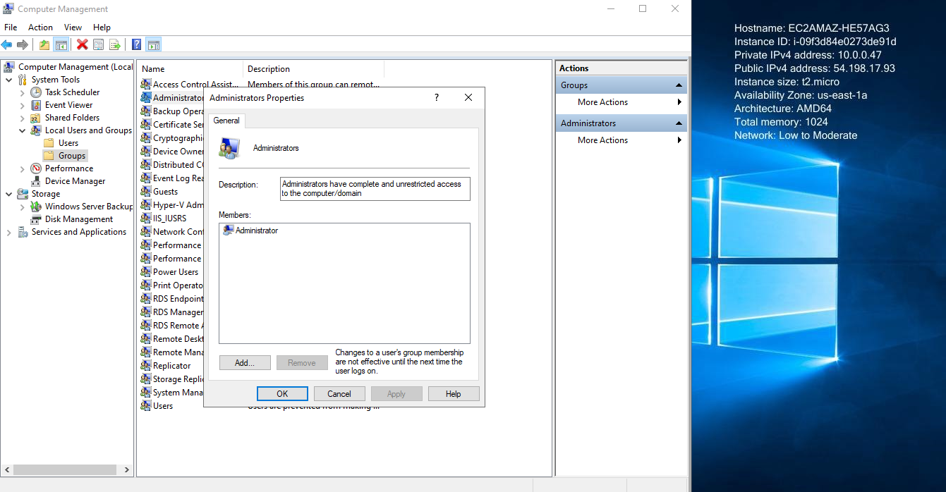

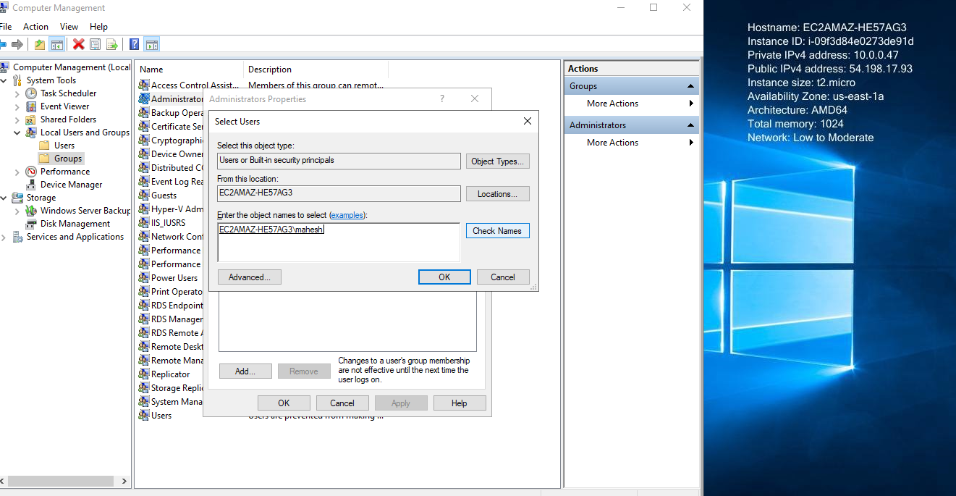

**Now login by user mahesh as well**

**By remote desktop**

**Type the command in run as mstsc**

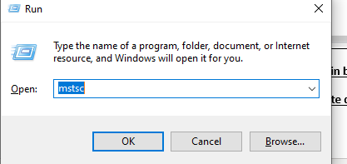

**And put the public IP**

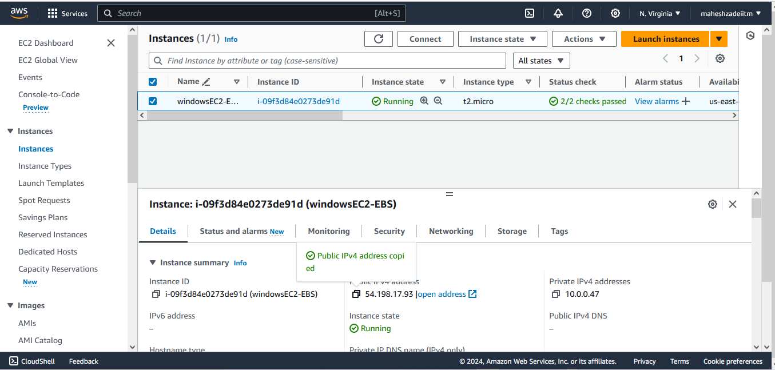

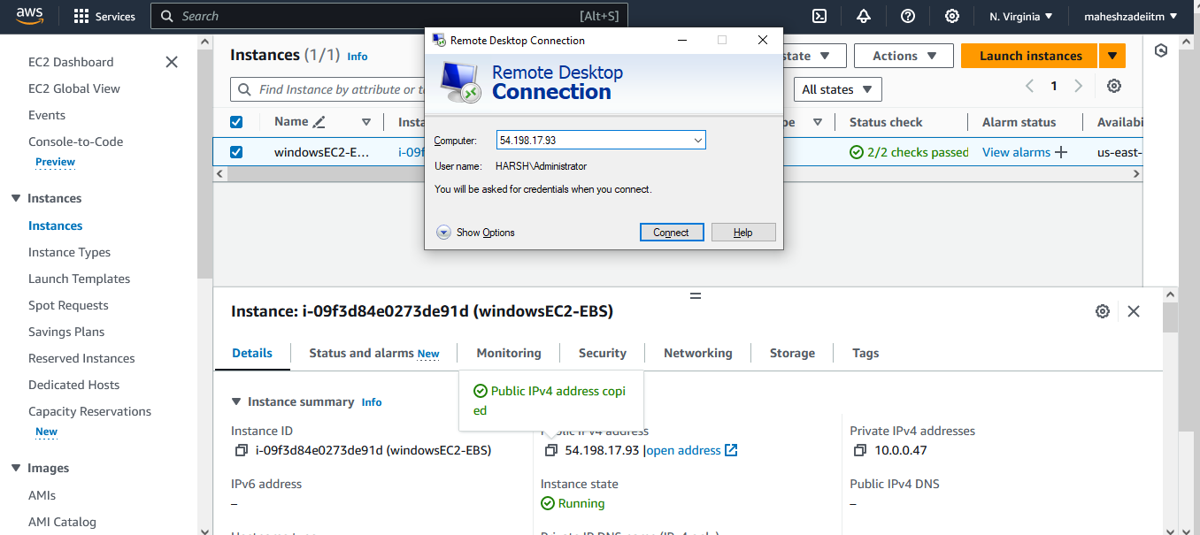

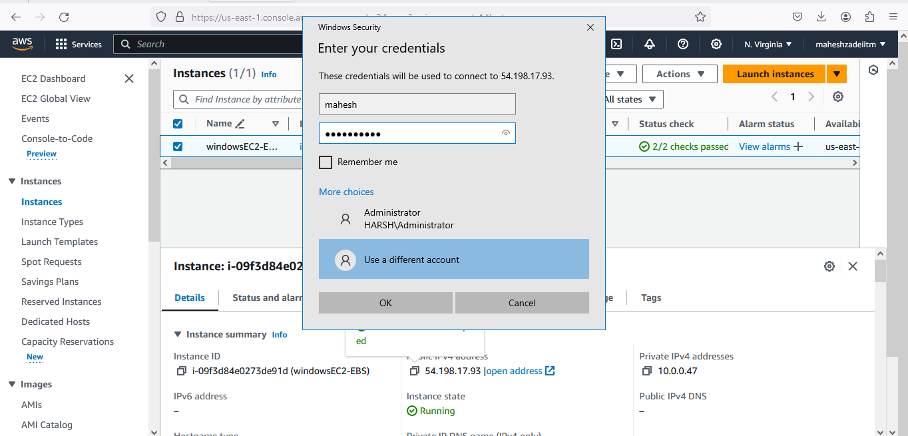

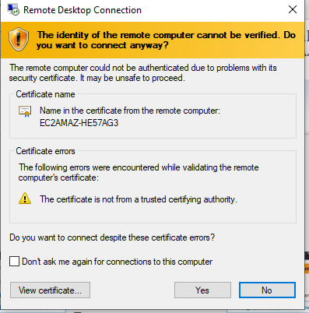

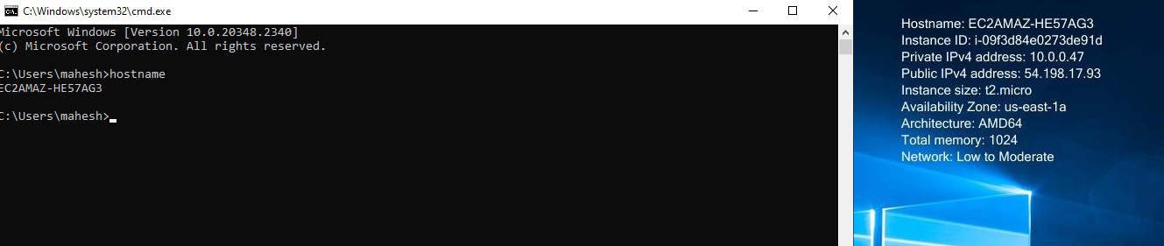

**And now for administrator user**

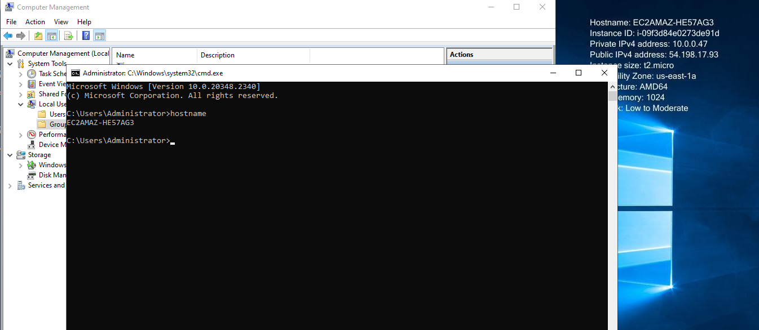

**Now Password change for administrator done**

**New user create tion done**

**Now I want to attach the volume to the EC2 instance**

**Now go to Volume of the EC2 instacne in AWS Console**

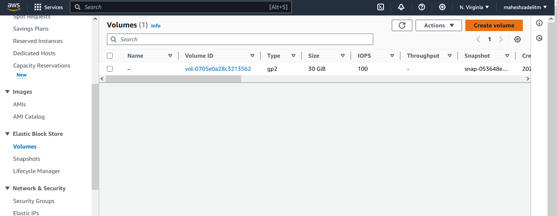

**Now click on create Volume**

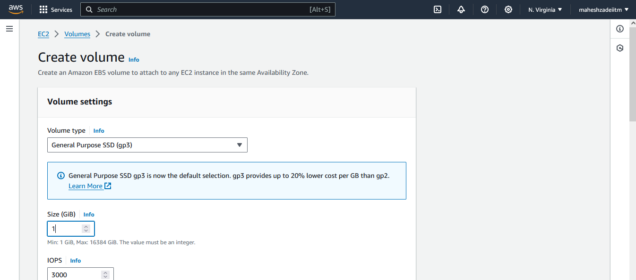

**Check the Availability Zone are Same while adding the Volume in EC2 Instance**

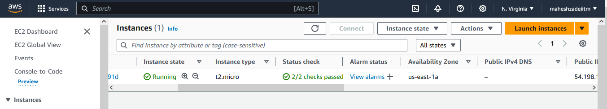

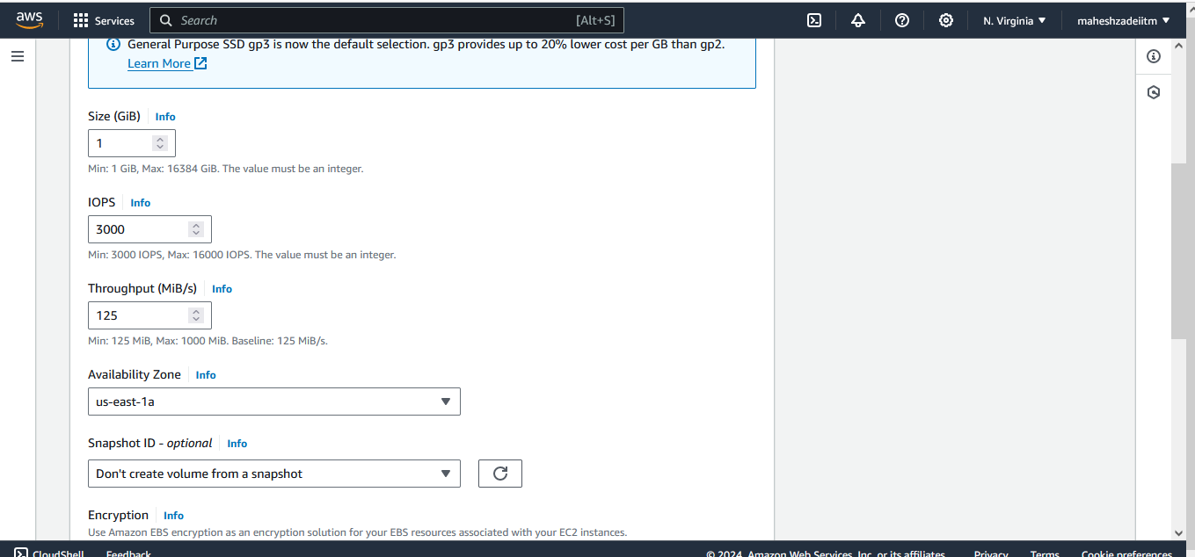

**Both are sam e**

**Click on create volume**

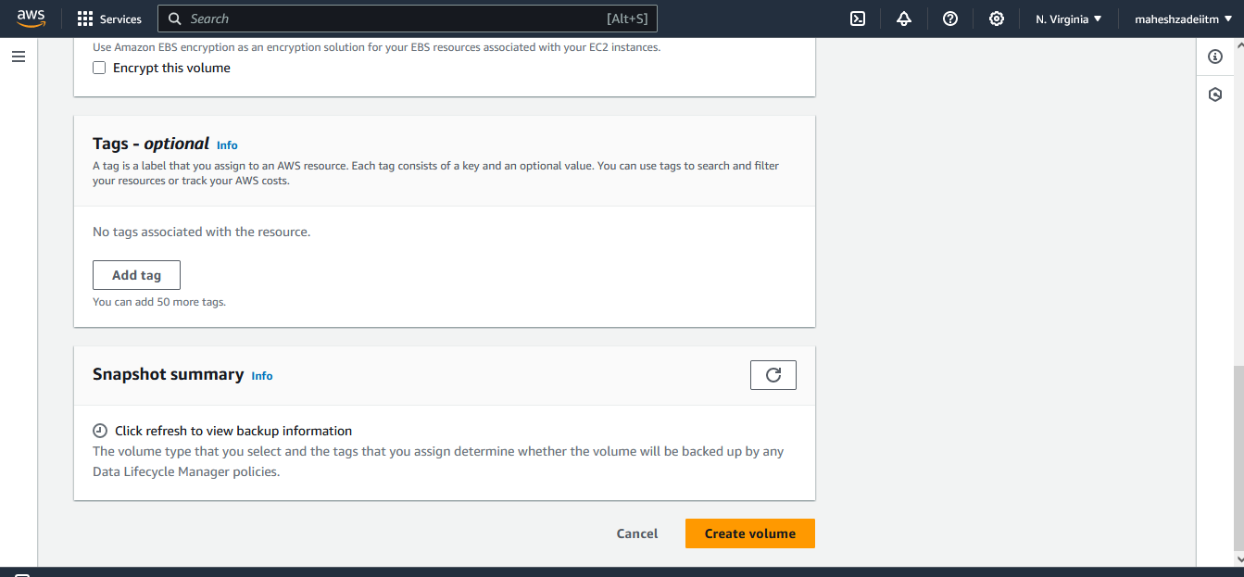

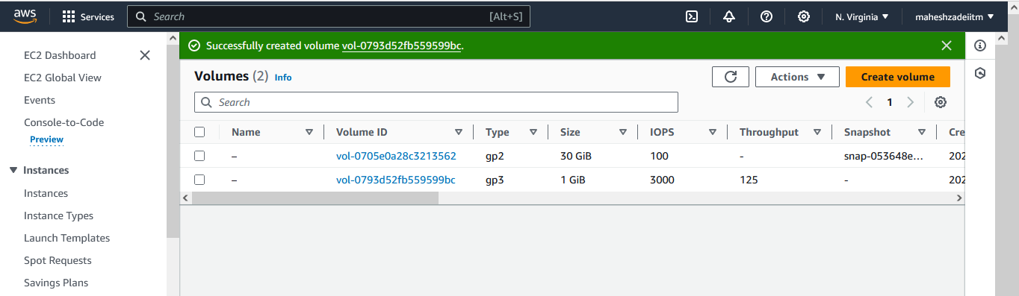

**Now attach volume to EC2**

**Go to action and click on attach volume**

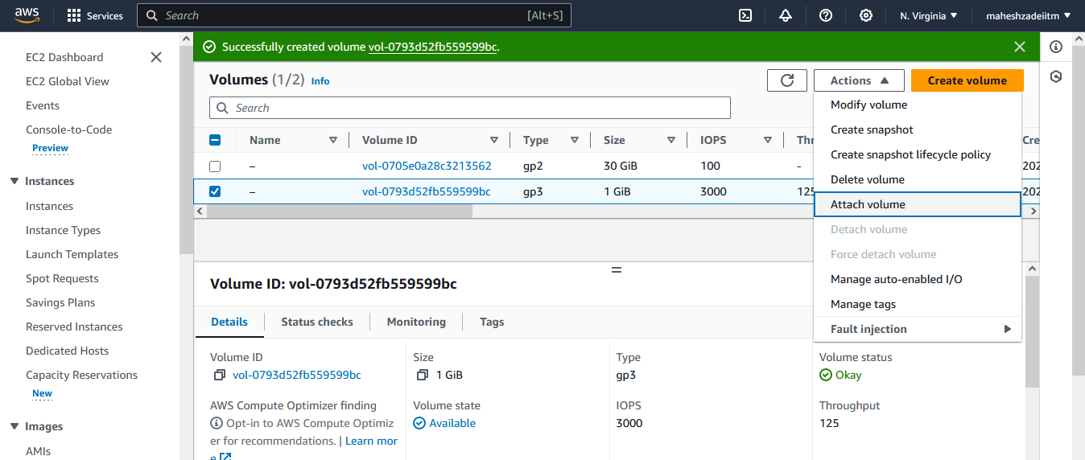

**Check instance ID**

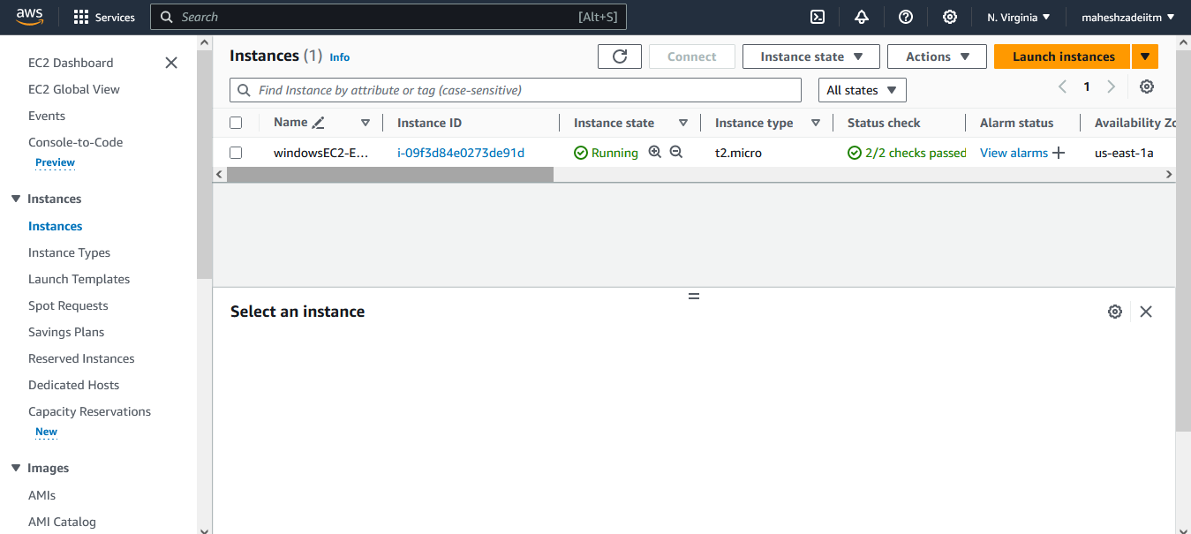

**Select instance and device name and then click on atta volume**

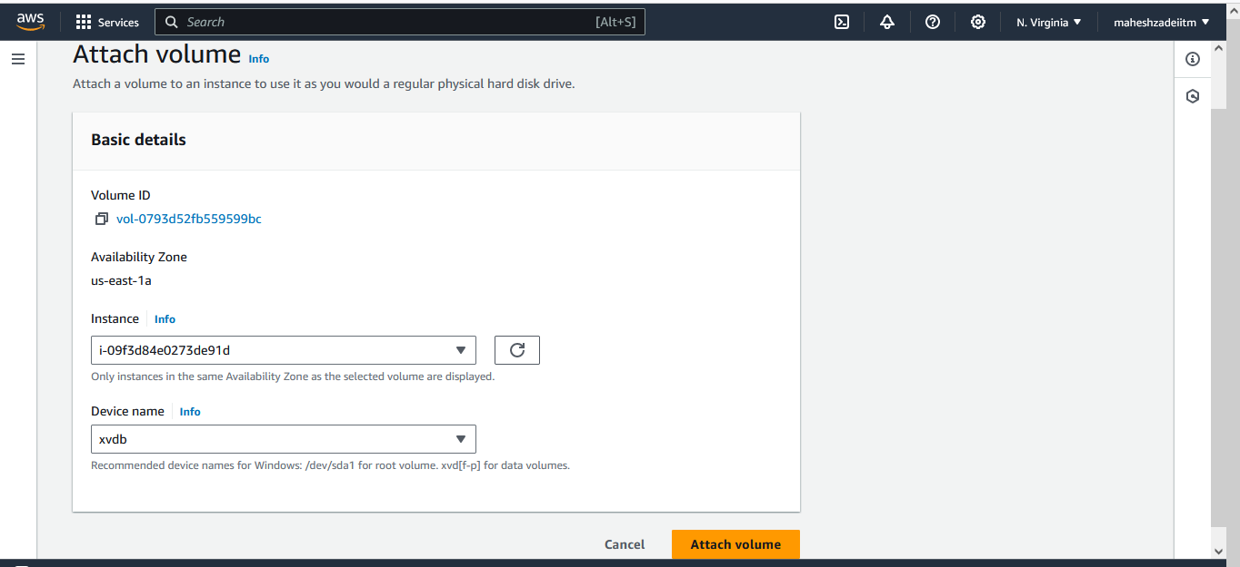

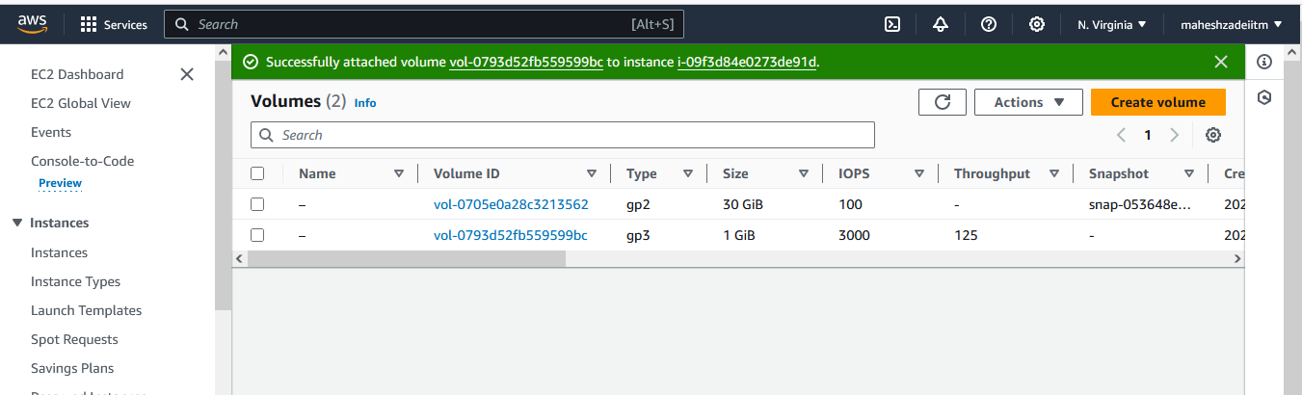

**Now go to EC2 login screen and attach the volune in VM**

**Go to Computer Management**

**And then disck management**

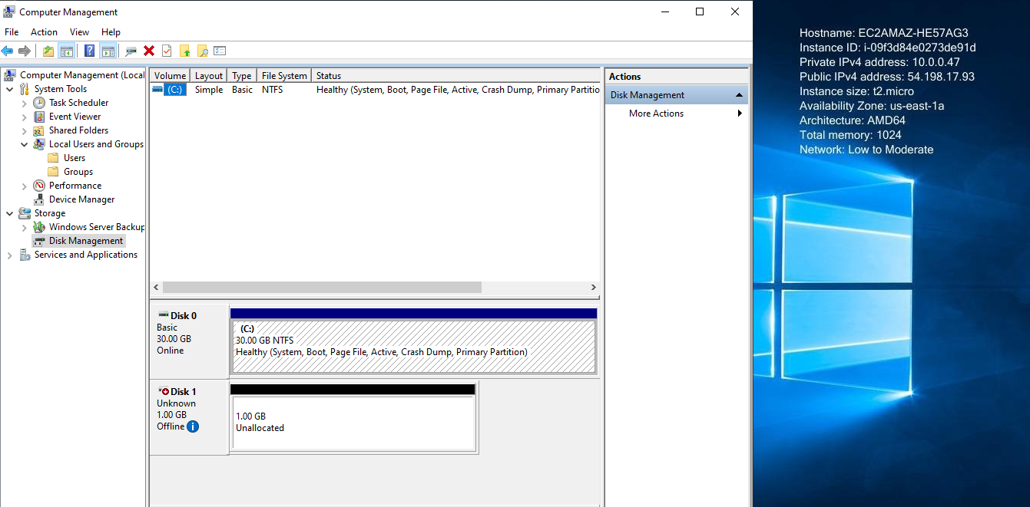

**Right click on disk 1 and make it online**

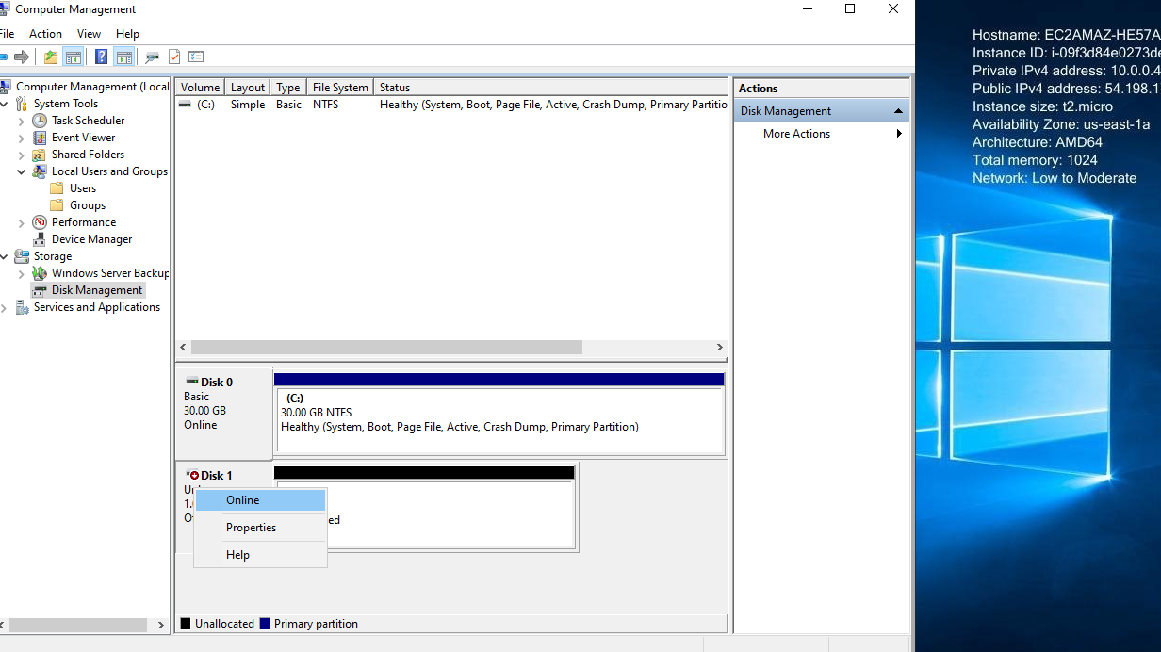

**Again clik on initialize the disk**

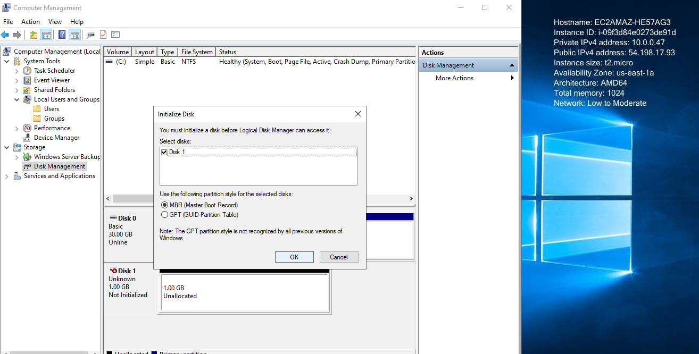

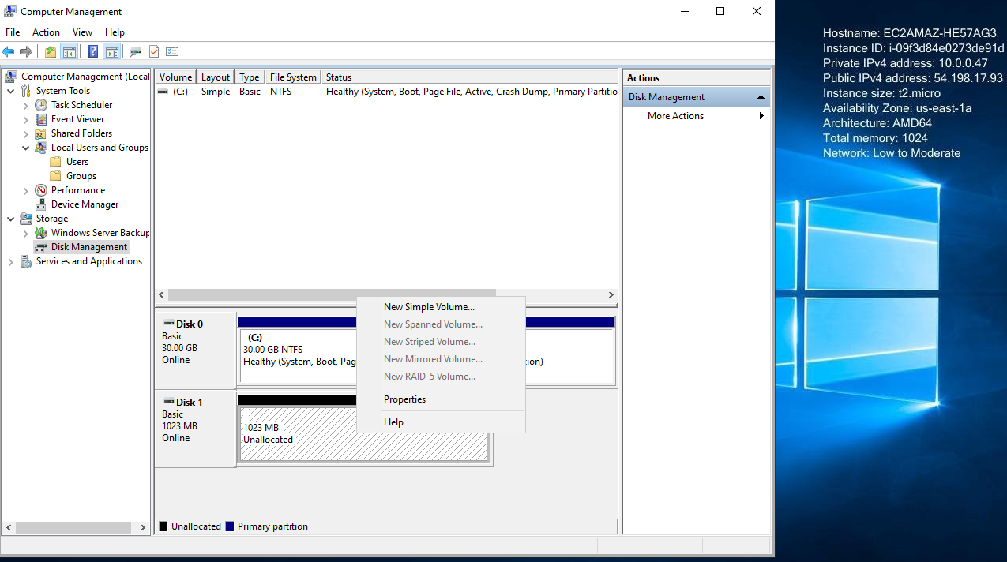

**Right click on new silpe Volume**

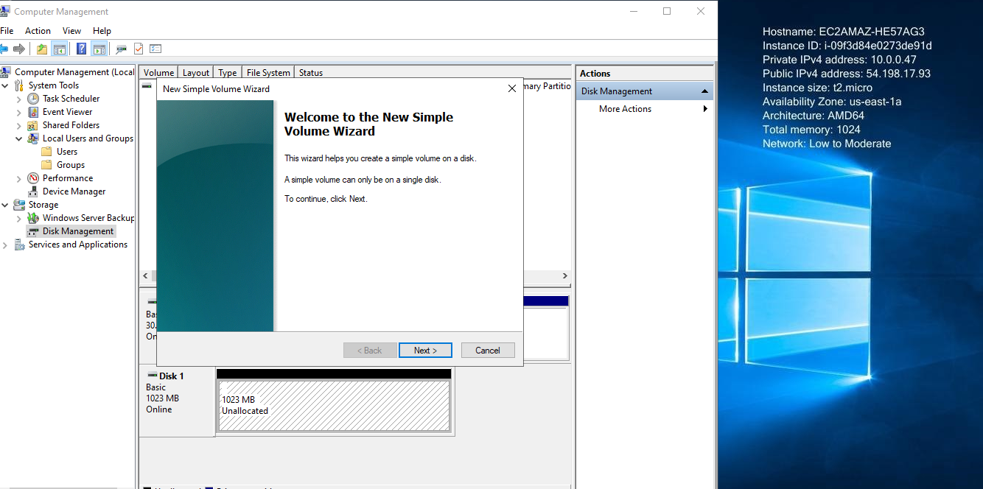

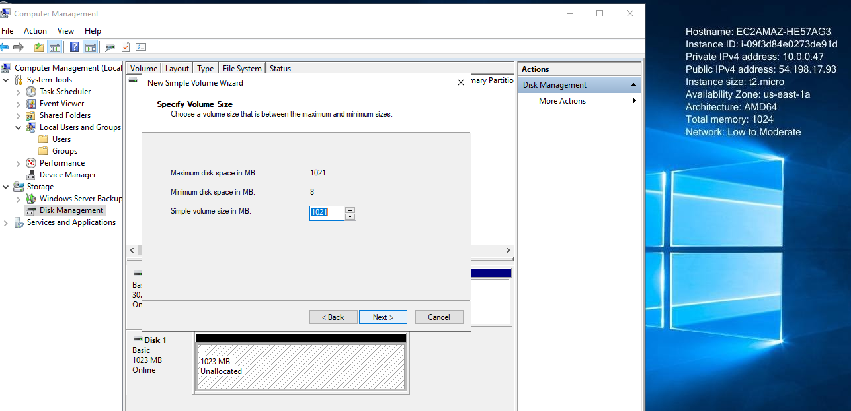

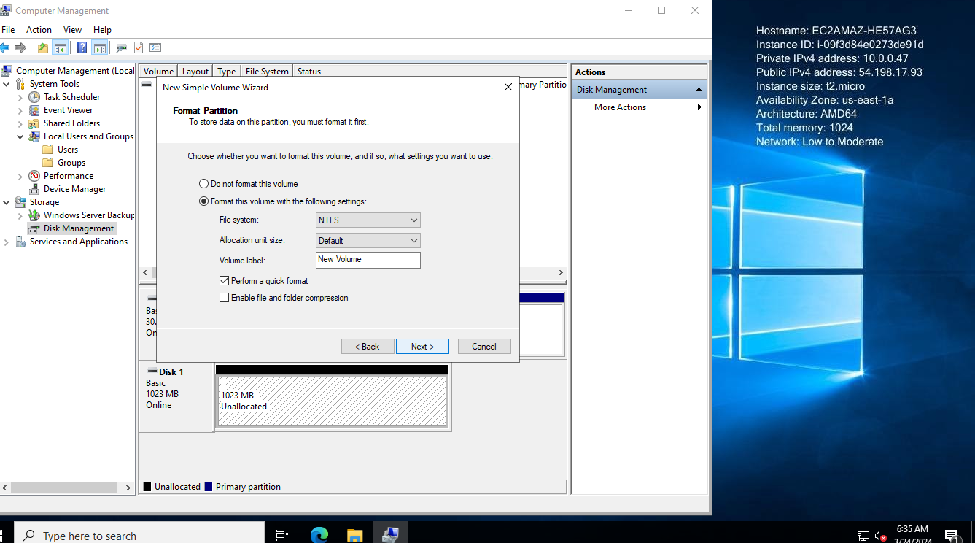

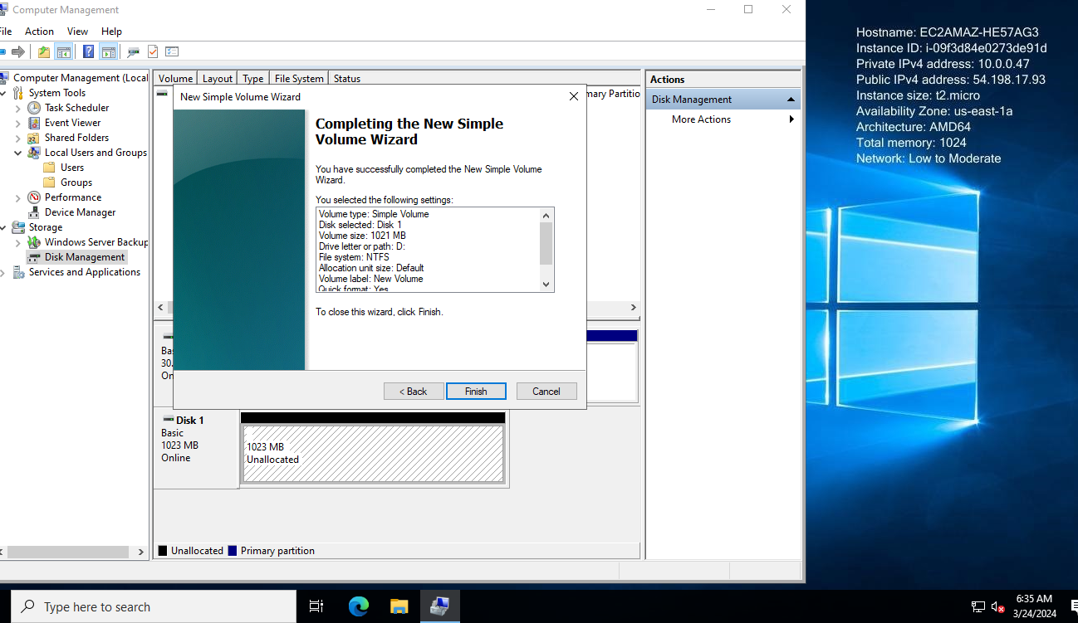

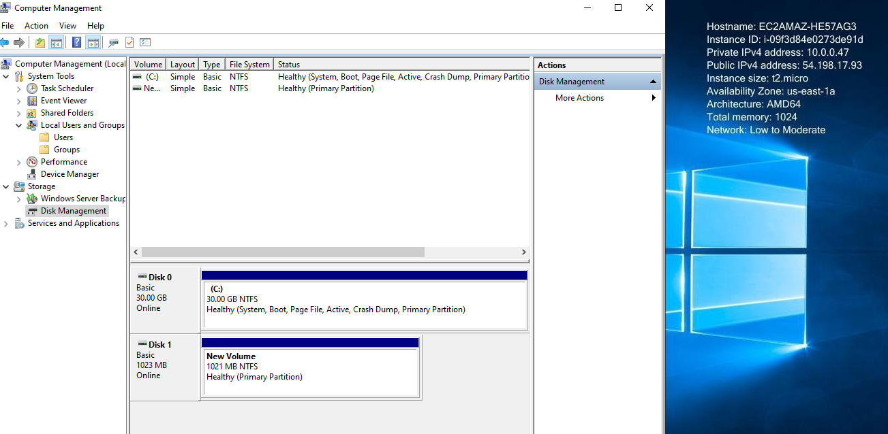

**Now 1 Gib Disk attached and working**

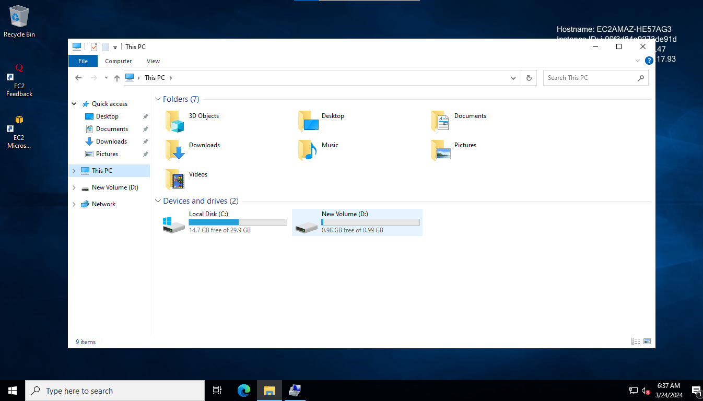

**Now upgrade the disk**

**Go to Aws Console and go to volune and select 1 Gib Volume**

**And upgrade to 2 GB**

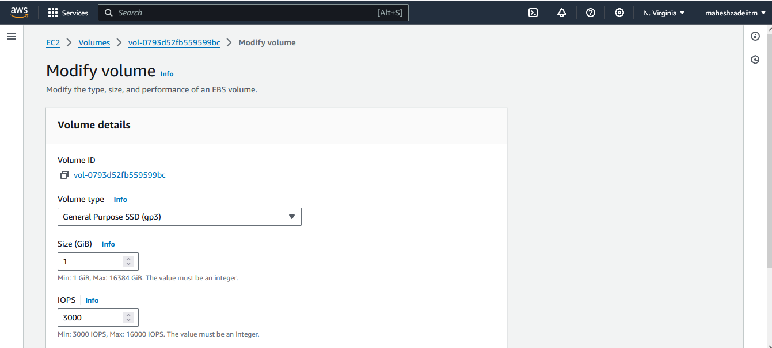

**Click on Modify Volume**

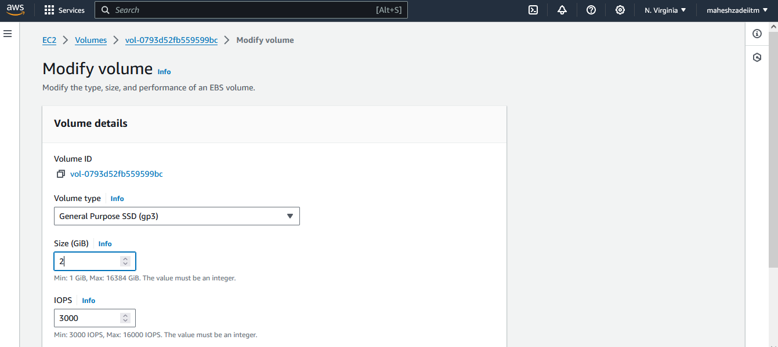

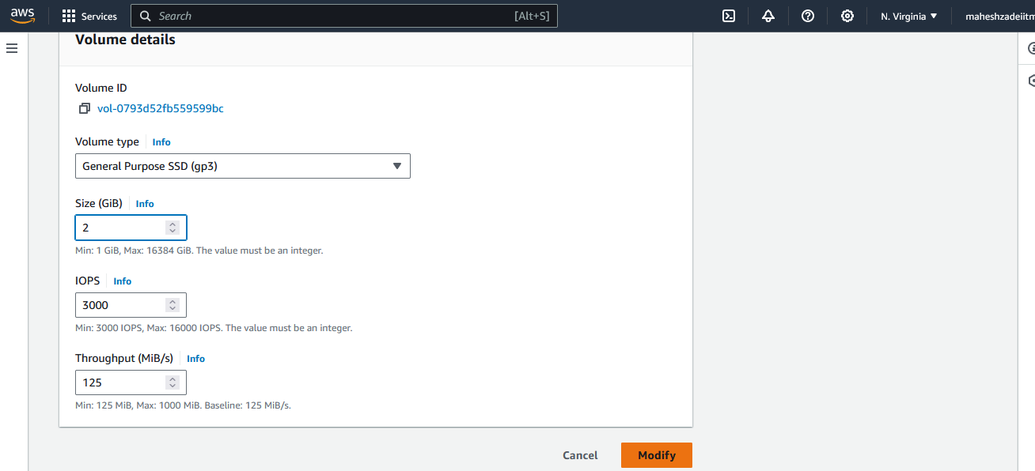

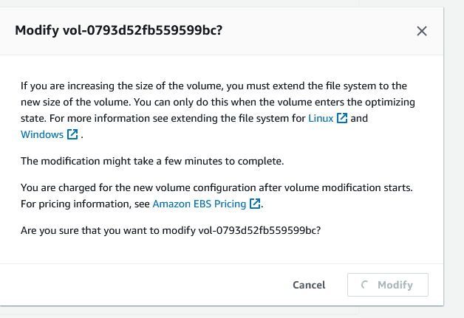

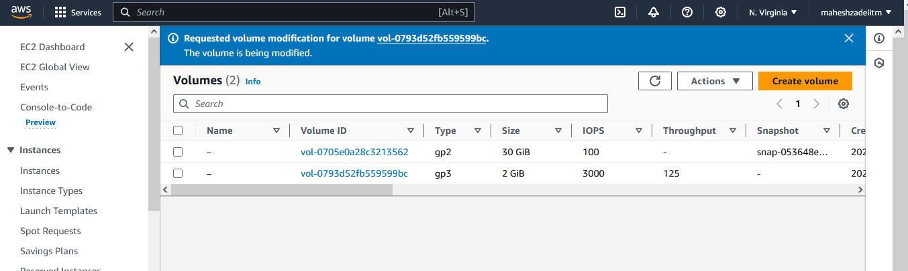

**Upgrade to 2 Gib but need to check in Ec2 Server inside**

**Go to EC2 Server**

**Computer Management and Disk Management**

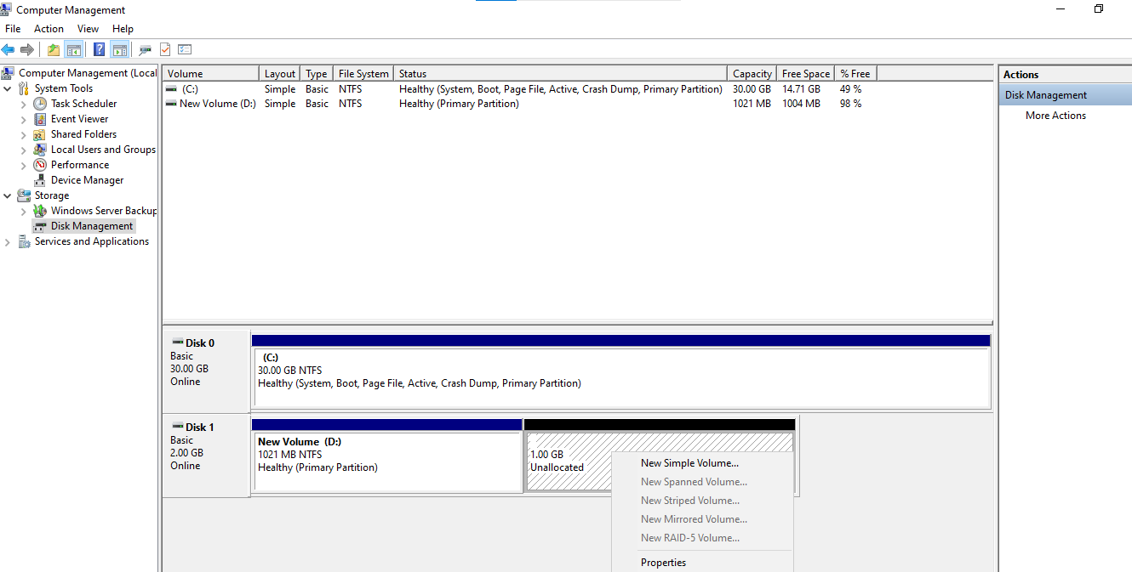

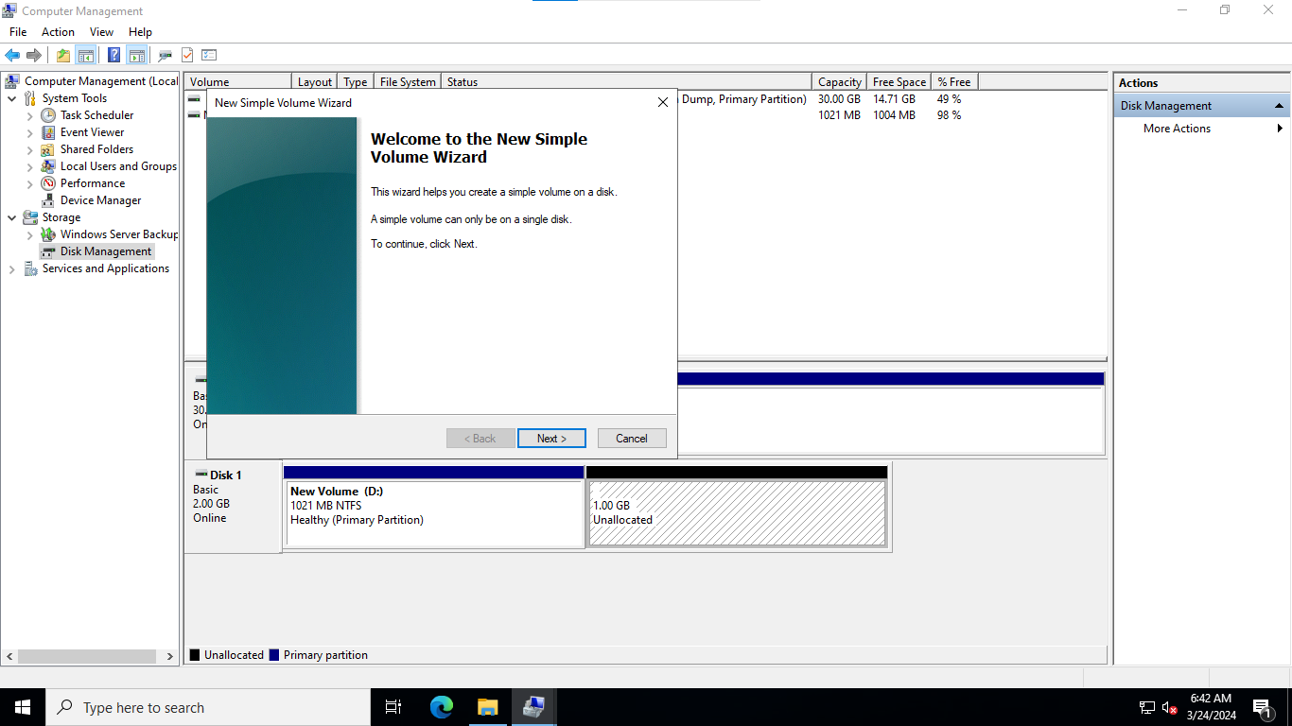

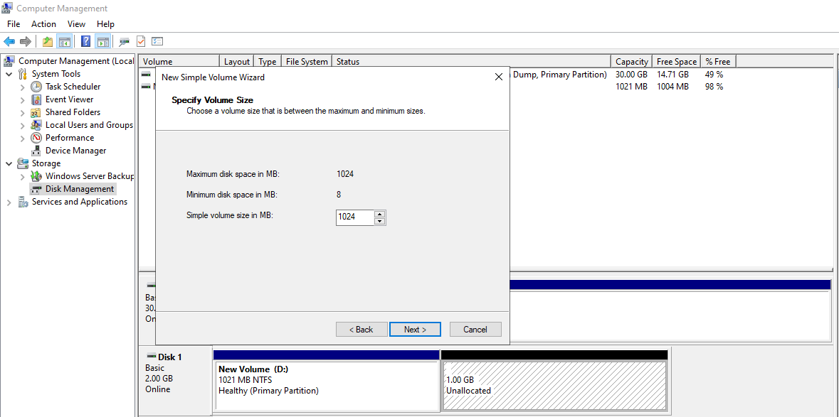

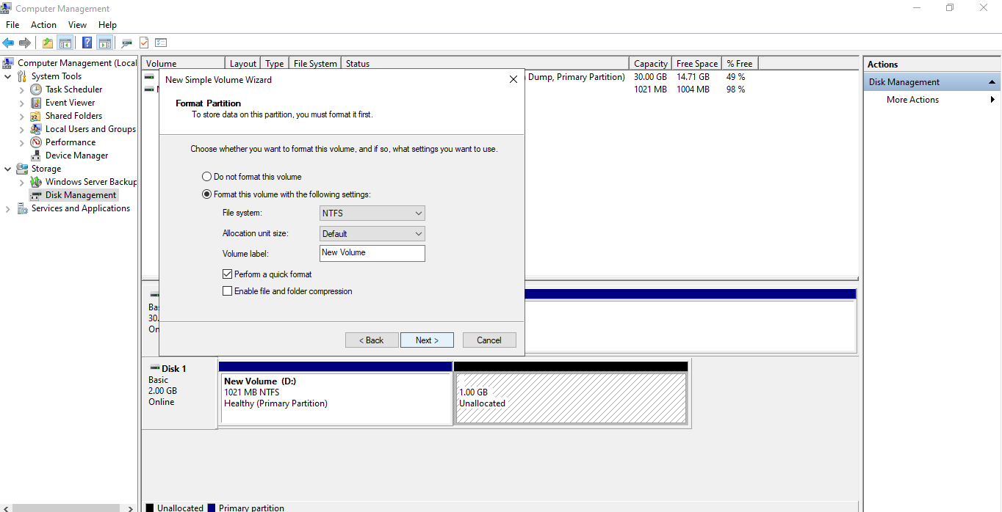

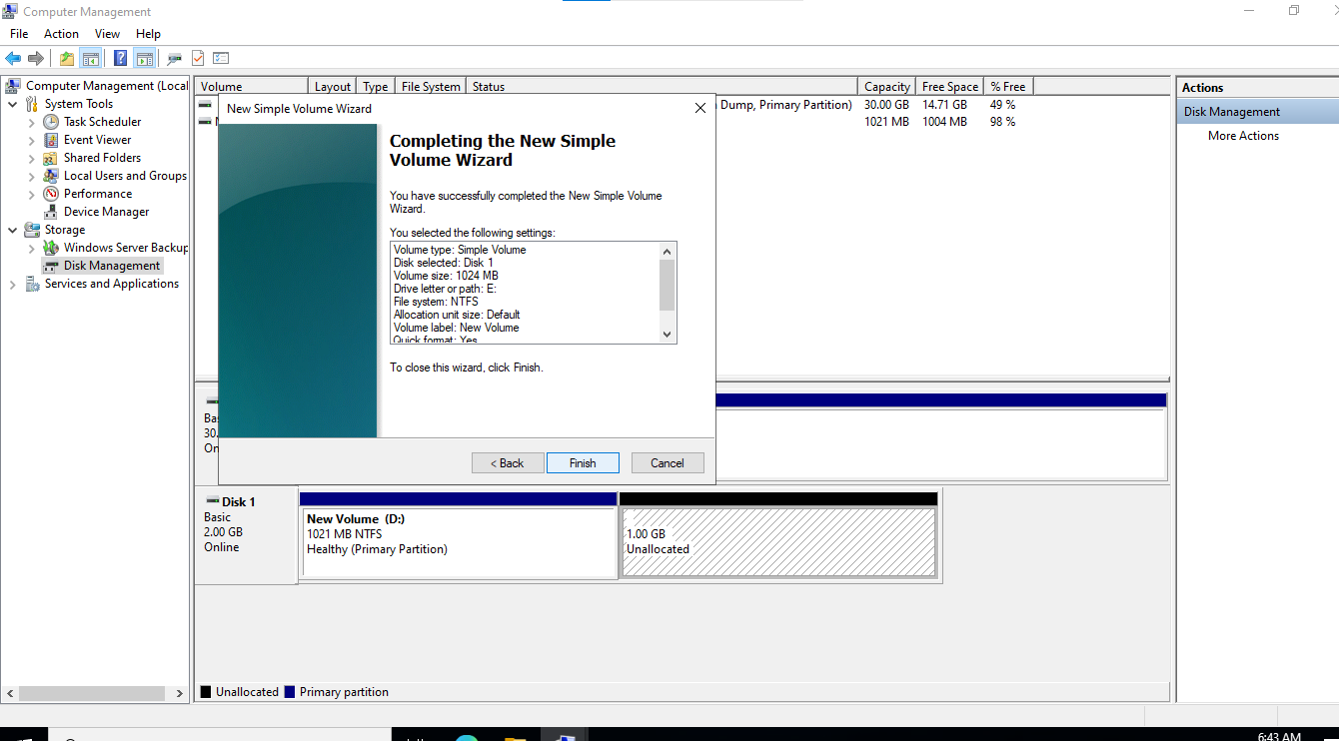

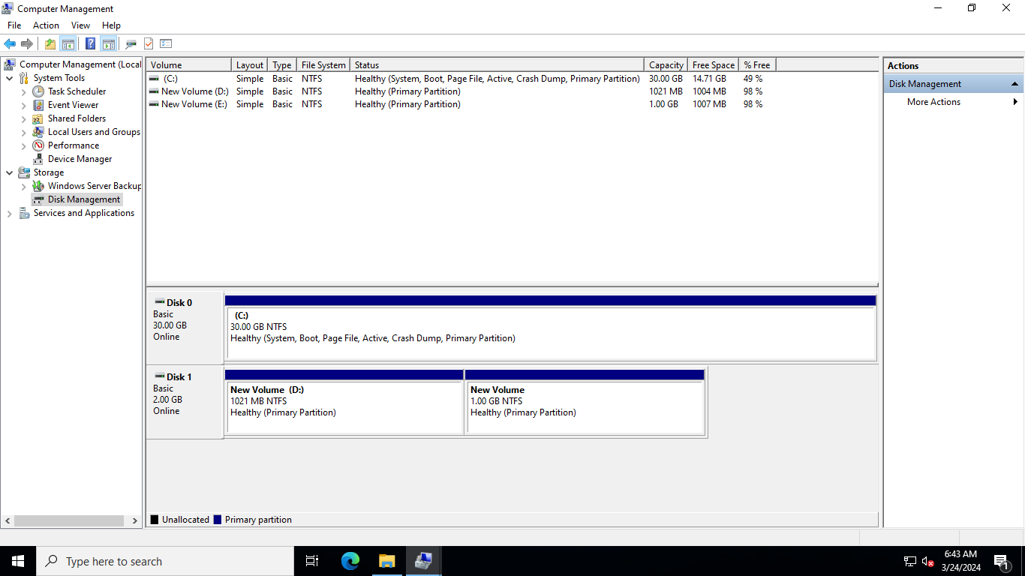

**Click on exted volume**

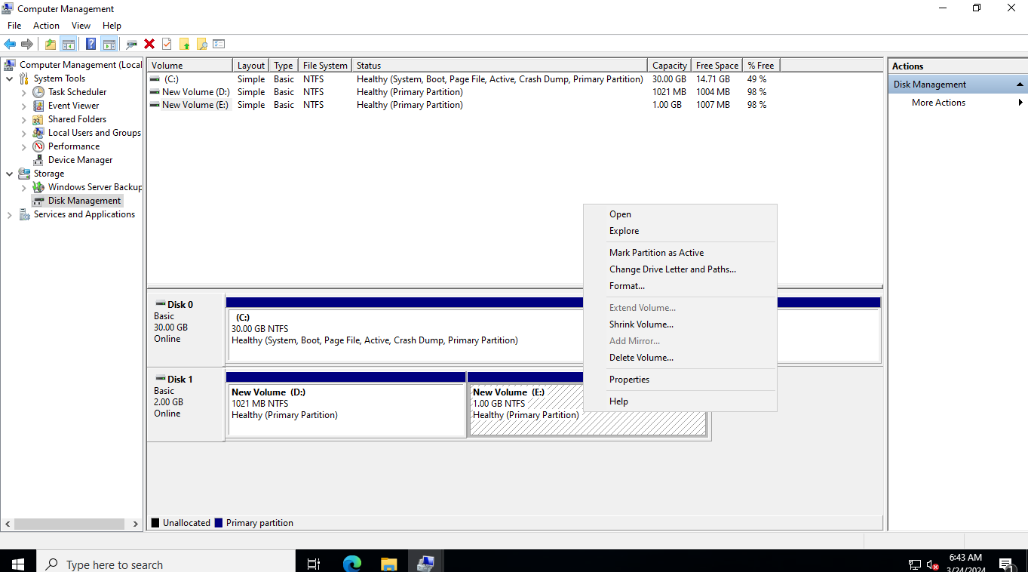

**Unable to extend the Volume .**